**Writing is a skill that is required in many contexts throughout life. However, academic writing is quite different from personal writing because it follows its own set of rules and practices: Ideas are usually organized in a formal order or structure. Ideas are supported by references from academic literature. In contrast to personal writing, academic writing is different because it deals with the theories and causes of a given topic, as well as exploring alternative explanations for these theories or events. Academic writing follows a particular tone, which uses concise, formal, and objective language. Academic writing also adheres to traditional conventions of punctuation, grammar, and spelling.**

**peteressayist@gmail.com**

Peter M. Gitiba

What is Academic Writing?

A Handbook of Academic Writing Guidelines

Contents

**ACADEMIC WRITING LEVELS** 6

**1.** **High School Level** 6

**2.** **Undergraduate (yrs. 1-2) Level** 6

**3.** **Undergraduate (yrs. 3-4) Level** 7

4. **Graduate, Ph.D. Levels** 8

AVOIDING REVISIONS AND DISPUTES 10

FORMAN AND INFORMAL ENGLISH 13

FORMATTING STYLES 16

APA Formatting Style 17

Running head 17

Title page 18

Abstract 19

The page following the Abstract 20

In-text citations 21

Reference to sources 23

Reference to Author(s) 24

Headings 25

References 28

Title Case and Sentence Case Capitalization in APA 29

Summing Up… 33

MLA Formatting Style 34

First page 34

In-text citations 35

Reference to sources 37

Reference to Author(s) 38

Headings 38

Works Cited 41

Summing Up… 45

Chicago Formatting Style 46

General Points 46

Title Page 46

First Page 47

Footnotes 48

Long quotations 53

Reference to Authors 54

Reference to Sources 55

Endnotes 56

Headings 56

Tables and Figures 58

Bibliography 60

Summing Up… 62

Harvard Formatting Style 64

General Points 64

Title Page 64

First Page 65

In-text citations 66

Reference to Sources 68

Reference to Author(s) 69

Headings 69

Reference List 71

Summing Up… 74

Formatting Styles: IEEE 76

Formatting Styles: OSCOLA 77

HOMONYMS 78

GUIDELINES ON ACADEMIC WRITING 80

Proper Paraphrasing 80

Types of Essays 82

Reliability/Credibility of Sources 83

Colon (:) vs. Semicolon (;) 84

Avoiding Contractions 85

Inclusive Language 86

Colloquialisms 87

Generalization 88

Avoid Personal Language 89

Be Concise 90

Objective Writing 91

Some Facts about Structure 92

Readability 93

ORGANIZATION AND STRUCTURE OF ESSAYS 94

Basic Elements of the Paper 94

Other Structural Elements of the Paper 94

Introduction 94

Ways to Start an Introduction 94

Thesis Statement 94

Ways to Give Background Information 95

Main Body 95

Conclusion 95

Reminding 95

Showing Importance 95

Afterthought 95

Outline 96

Tips for Creating Outlines 96

Outline Style Options 96

Outline Formatting Options 96

Abstract 97

Summary 97

Difference 97

Tips for Arranging Paragraphs and Developing Main Points Clearly 97

PARALLELISM 99

PLAGIARISM: WHAT IT IS AND HOW TO RECOGNIZE AND AVOID IT 100

What is Plagiarism and Why is it Important? 100

How Can Writers Avoid Plagiarism? 100

How to Recognize Unacceptable and Acceptable Paraphrases 100

Plagiarism and the World Wide Web 101

Strategies for Avoiding Plagiarism 102

Terms You Need to Know ( or What is Common Knowledge ? ) 102

**SUBJECT-VERB DISAGREEMENT** 104

Types of Subject-Verb Disagreement (correct examples are in the right-hand column): 104

THESIS STATEMENT: HOW TO MAKE IT STRONGER 106

What is Thesis Statement 106

A Thesis Statement: 106

Is Essay Without a Thesis Statement Possible? 106

How Do I Get a Thesis? 106

What Is a Strong Thesis? 107

*Is my thesis statement clear?* 108

*Does my thesis include a comment about my position on the issue at hand?* 108

*Is my thesis statement original?* 110

Five kinds of weak thesis statements 111

GRAMMAR AND STYLE 113

Proper Use of Tenses 113

Correct Sentence Composition 113

Proper complex sentence structure 113

Proper Style 114

Improving your style tips 114

Repetitions 117

Using transitions 117

PAPER STRUCTURE 119

Basic Elements of the Paper 119

Organization of ideas 121

Sentence Variety 122

RESEARCH SKILLS 124

Sources Selection 124

Analysis Evolution 125

Checklist for a Proper Argument 125

USING GRAMMAR AND STYLE CHECKER 127

Instructions 127

New Sentence: 127

Passive Sentences 128

New Sentence: 128

Active Voice - 128

Practice Instructions: 130

WRITING STYLES 132

Awkwardness 132

Parallelism 132

Mixed construction. 132

Nominalization. 133

Passive voice. 133

Wordiness. 133

A Summary of Writing Tips 135

**ACADEMIC WRITING LEVELS**

**It is important to distinguish different academic levels as a writer to know where yours skills lie and where to improve.**

1. **High School Level**

Key characteristic: **Description** (the level presupposes that the writer is able to describe theories, experiences, opinions; use some research findings to illustrate points (but they are taken ‘at face value’).

**Content / Ideas**

There are very few good arguments. Most ideas come from a writer’s own views and attitudes. Only major information is presented. The paper's focus is on general ideas; only one point of view is presented. The writing is usually a short essay (4-6 paragraphs) or question-answer paper.

**Paper Structure, Composition, & Ideas Organization**

The writing does not have a clear central idea, and/or it presents weak response to the assignment. Thesis may be absent, too vague or mixed with a purpose statement. Information borrowed from the sources is often distorted and/or wrongly interpreted. The written piece may fail to cover some parts of the assignment and neglect sources usage. A clear paragraph structure is usually missing. There are poor or partial logical connections between sentences. In some cases, subsequent ideas and arguments may be unrelated (some sentences may have no sense at all).

**Grammar & Style**

There are many problems with punctuation, the use of prepositions and articles, tense agreement, etc. Style is a bit awkward and primitive. There are poor word choices, repetitions, redundancy cases, tautology, etc.

**Sources & Formatting**

Occasional formatting mistakes take place: citing, referencing, indents, fonts, spaces, etc. Sources and in-text citations may be missing, incomplete, or presented in a scattered manner.

1. **Undergraduate (yrs. 1-2) Level**

Key characteristic: **Discussion** (the level presupposes that the writer is able to compare and contrast different research findings, opinions, and experiences).

**Content / Ideas**

The paper content is adequate but less effective, possibly responding less accurately to assignment. A College paper presents and discusses a central idea in general terms, which is often based on a personal attitude or cliches. The view point taken in the paper usually does not acknowledge other views. It demonstrates the adequate comprehension of source(s); however, there may be lapses in its(their) understanding.

The writing is based on some research (it does not simply describe matters completely unfamiliar to a writer). Controversial topics are possible. Both opinions and reasoning are demonstrated. Positions and views are underpinned by some argumentation. However, underdeveloped arguments and simplified explanations take place from time to time.

**Paper Structure, Composition, & Ideas Organization**

The plan and purpose of the essay are not always distinct. Some paragraphs may be underdeveloped, or there may be some irrelevancy or redundancy. Transitions are weak or lacking. A thesis statement (not always strong) is present. However, topic sentences in body paragraphs are provided in all paragraphs. Some minor deficiencies of a paragraph structure are possible. A conclusion is summary-like.

**Grammar & Style**

There are quite long and complicated sentences, which are logically connected by transitions (some of them are not smooth/weak though). Run-on sentences and cases of awkwardness (understandable words but unclear sentences on the whole) occur. The poor diversity of the vocabulary is likely, which results in some repetitions, redundancies, and tautology. Occasional punctuation and grammatical mistakes also take place. Often, the writer repeats points in thesis, body, and conclusion.

**Sources & Formatting**

The information from sources is not adequately incorporated into the body of the essay (e.g., "drop quotes'') at times. The writer is too dependent on sources and sometimes fails to demonstrate a substantial discussion or the synthesis of ideas under consideration. References may contain minor flaws. Most rules of formatting styles and the general organization of the text are followed.

1. **Undergraduate (yrs. 3-4) Level**

Key characteristic: **Critical analysis** (the level presupposes that the writer is able to view different research findings, opinions and experiences critically; use ‘good’ evidence as a basis for drawing conclusions).

**Content / Ideas**

The paper itself is solid and responds appropriately to assignment. In most of a paper, well-developed arguments supported by documented facts, statistics, and studies are present. A thesis/central idea is easily defined, but it may have minor lapses in its development. The thesis also acknowledges the complexity of a central idea and the possibility of other points of view. In such works, a writer’s own research is needed. There are the specific topics that require a problem’s thorough analysis.

**Paper Structure, Composition, & Ideas Organization**

The thesis is apparent but perhaps too general or commonplace and not always very strong. The content is properly organized (introduction, main body, and conclusion are present). All paragraphs are well-structured.

**Grammar & Style**

Solid knowledge of grammar is demonstrated. The sentences are correctly constructed, but they may sometimes lack distinction, creativity, or style. Words are generally used correctly, and the vocabulary is academic. There may be some rare lapses in grammar, punctuation, or spelling.

**Sources & Formatting**

All academic sources used are appropriately cited and referenced. Only some sources used may be too general or lacking in authority. Citing, referencing, and general formatting have no flaws.

1. **Graduate, Ph.D. Levels**

Key characteristic: **Critical analysis, synthesis and evaluation** (the level presupposes that the writer is able to conduct an in-depth research or critical analysis of research findings, use scholar's opinions and experiences to construct an argument, justify a particular viewpoint or conclusion as a result of evidence evaluation; critically evaluate materials, make complex conclusions, and provide extraordinary points of view).

**Content / Ideas**

A Master's paper is the compelling writing which addresses the assignment and demonstrates the sophistication of a thought. The paper recognizes the complexity of its thesis: it may acknowledge its contradictions, qualifications, or limits and follow out their logical implications. It also appropriately limits and defines terms. The writing is based exclusively on a solid research. Deep content is related to a very narrow topic or idea.

**Paper Structure, Composition, & Ideas Organization**

Content is planned logically and progresses in clearly ordered and necessary steps. Ideas are arranged in distinct paper parts and well-structured, cohesive paragraphs. The transitions between paragraphs are effective and to the point. A thesis statement is clearly defined, supported by relevant facts, and also considers counterarguments. Reasoning is supported by precise data: statistics, reports on experiments, graphs, etc.

**Grammar & Style**

The sentences are skillfully constructed, effective, and varied. Words used are vivid, accurate, and original. The writing is free of serious flaws in grammar or mechanics. The writing style also corresponds to theacademic level of the authors reviewed (from analyzed sources) and follows the rules of scientific prose. Perfect skills of paraphrasing are demonstrated. There is evidence of a distinct personal style.

**Sources & Formatting**

Sources used are relevant and authoritative. Borrowed ideas are incorporated smoothly and appropriately. Statistics and visuals are to the point and correct. Citing, referencing, and general formatting have no flaws.

# AVOIDING REVISIONS AND DISPUTES

**How can you ensure that you are doing the right thing to avoid revision calls and disputes from a customer?**

While checking an order, the **DRS** (Dispute Resolution Specialists) adhere to the following procedure:

1. They review the customer's claims about the dispute and previous revision requests if any. Then they compare the client's feedback with the initial instructions to make sure the complaint is valid.
2. They read the paper and check whether the mentioned issues are present in the work.
3. Particularly, they check if the paper follows the initial instructions, meets the required formatting and grammar standards, contains citations to reliable sources, and overall corresponds to the academic level selected by the client. Even if the writer was only assigned to complete a specific revision, all the initial instructions should be followed and the highest quality paper should be delivered to the customer.
4. They either decline the customer's refund request or agree with the claims and issue a full/partial refund. The change of the writer’s bid usually reflects the type of the refund; whenever the paper shows the genuine effort and meets the initial requirements, the writer’s work is compensated.
5. They might mark the dispute as "Writers fault" in cases when the writer's actions or the lack of cooperation have led to the dispute. This decision affects the writer's rating.

*Failure to follow instructions* is the cause of 90% of disputes. This factor in essay writing is hardest to control mostly due to complexity of some assignments. Still, definite tips will be useful in minimizing the chance for having your order on revision or dispute due to failure to follow instructions:

1. First and foremost, it is important to **adequately assess your skills** and scope of understanding. Carefully evaluate the instructions and check whether you understand the topic. While some orders may be quite seducing in terms of financial reward you should be careful as such assignments may come at a price. Therefore, temper your greed:); it is better to write two ‘cheaper’ papers than one that you know you won’t complete as requested.
2. **Carefully read and understand the instructions.** Instructions are the bone of your essay. They define what the essay will be about and narrow the topic of your research.
3. **Proportionate your writings according to your tasks.** Quite often when you need to answer several questions or cover a couple of points you might spend the bulk of an essay on answering one question and squeeze the rest of your questions into the remaining 1-2 pages. Please refrain from that and try to allocate equal space for each question you have to cover.
4. If you have problems sticking to the topic, **prepare an outline**:
   1. write down the key points that need to be covered on a separate sheet,
   2. enumerate them from most to least important,
   3. shortly outline the answers and references,
   4. write down questions that you might come across,
   5. Place this sheet of paper in front of you and every now and then check whether you are still following your outline. This tip is especially useful for short essays. On one hand, such outline keeps you stuck to the original instructions; on the other, it delimits the scope of your study and reminds you of the points you haven’t yet covered.
5. Do not be afraid to **ask questions**. Often, one or two questions timely posed before the customer may solve your riddles.
6. **Go through your instructions in time**. It is a case with non-urgent orders that the writers fail to timely read through the guidelines and as a result fail to follow them accordingly. Actually, it is much better for you to make an outline beforehand. For example, you have been assigned a paper which is due in 10 days. Spend half an hour now, read the instructions, prepare an outline right away. Then feel free to put it aside for a while i you have other urgent things to do. At least, you will be sure that you understand the topic and do not need more clarifications from the customer.
7. If you see that your ***paper takes more space****than requested*, you must focus on valuable information and remove what can be removed so that the essay fits the required amount of pages without losing its value.
8. Always perform a **spell check**. To minimize the probability of revisions you must always perform a spell check. Spell check tool underlines grammar mistakes. This function should be properly tuned in your MS Word and similar systems.
9. Always **provide real references.**Majority of your references are later verified up to the page number. Incorrect sources will mark the paper as plagiarized.

We would also like to point you at definite features in your work with revisions. The following are the recommendations received from the dispute department. Please, keep them in mind since they are based on the history of disputes that could have been avoided.

* Whenever you undertake to complete a revision after another writer, you assume the **full responsibility** for completing that order. And it is instrumental to understand that word 'full' here. Even in a case where the revision instructions precisely state to correct grammar, the writer who undertakes to complete such revision is also responsible for correcting other irregularities, like missing references, wrong format etc. It is your utter responsibility to make sure that in the end the paper meets all the requirements the customer made.
* Be attentive with the **'writer's choice'** topics. We insistently recommend urging the customer to give more details and specify what exactly he/she would want the paper about. Do not start writing the paper unless you are absolutely sure what to write about. Exceptions are only possible with urgent orders where the customer allows 8 or fewer hours for completion. But even in such cases, you should ask the customer to specify the topic ASAP. Failure to do that often leads to unnecessary revisions, cancellation of orders etc.
* Please, keep '**regional features**' in mind. The customers may sometimes forget to specify which exact country the paper should be about. For example, your paper requires you to write about the structure of parliament. After having written the paper the writer is surprised to see the paper on dispute since the paper was supposed to be about the Parliament of the U.S., and the writer wrote about the Parliament of Kenya. In such cases we recommend you to ask the customer about the further details, especially if the time allows.

# FORMAN AND INFORMAL ENGLISH

**In Academic Writing, it is important to distinguish between formal and informal English**

In short, formal English is used in writing essays, cover letters to apply for jobs, or emails and letters at work. Informal English is used in every day communication with friends and relatives. Informal English includes various terms and expressions that are not used by the majority of English speakers. Speaking of informal English we mean colloquialisms, jargon and slang.

There is a certain difference between the slang, jargon and colloquial terms. Slang is used in definite social groups (for example among the teenagers); colloquialisms are commonly used across age and socioeconomic groups; jargon is a set of terms used in a particular professional setting (IT, law, medicine). Definite informal terms may be vulgar and inappropriate in specific situations. Some terms are not understood by the non-native speakers or vice-versa. Irrespective of the differences between these concepts colloquialisms, slang and jargon are parts of informal language, which is not used in formal and academic writing.

By contrast, formal English presumes professional language and choice of terms. The following table will help you choose proper terms and avoid informal counterparts that diminish the quality of your formal writing.

Please, also review the 'Colloquialisms' section of our Manual on Academic Writing.

| **Informal** | **Formal** | **Informal** | **Formal** |
| --- | --- | --- | --- |
| & | and | deal with | handle |
| anybody | anyone | seem | appear |
| big | large, great | cell | cell phone |
| get | receive, understand (depending on context) | net | Internet |
| kind of/sort of | type of | keep | retain |
| on the other hand | conversely, by contrast | free | release |
| so | because | put up | tolerate |
| movie | film | ring up | call |
| kid | child | show up | arrive |
| a bunch | a group | let | permit |
| mom | mother | get | obtain |
| dad | father | photo | photograph |
| say sorry | apologize | give the go ahead | authorize |
| go up | increase | anyways | nevertheless |
| go down | decrease | plus | moreover/ furthermore |
| set up | establish | but | however |
| look at | examine | so | therefore |
| blow up | explode | also | in addition |
| find out | discover | ASAP | as soon as possible |
| bring about | cause | Okay, OK | acceptable |
| put off | postpone, delay | In the meantime | in the interim |
| rack up | accumulate | I think | in my opinion |
| make up | fabricate | in the end | finally |
| stand for | represent | to sum up | in conclusion |
| find out | discover, ascertain | in a nutshell/basically | to summarize |
| leave out | omit | lots of/ a lot of | much, many |
| point out | indicate | tons of, heaps of | a number of |
| go against | oppose | need to | required |
| get in touch with | contact | think about | consider |
| it is about | it concerns | smart | intelligent |
| T.V. | television |  |  |

# FORMATTING STYLES

This section will guide you through the most commonly used formatting and citation styles. The most common citation styles are:

* APA (American Psychological Association) is an author/date based style, where emphasis is placed on the author and the date of a piece of work to uniquely identify it. APA is most commonly used to cite sources within the social sciences;
* MLA (Modern Language Association) style, which is used to write papers and cite sources within the liberal arts and humanities;
* Chicago and Turabian, which are two separate styles but are very similar, just like Harvard and APA. They are widely used for history and economics;
* Vancouver, which is mainly used in medical and scientific papers;
* Harvard. Where APA is primarily used in the USA, Harvard referencing is the most well used referencing style in the UK and Australia, and is encouraged for use with the humanities. We recommend our writers to settle it with the customers, which manual for Harvard referencing should be used in each specific case. While the common US formats like APA, MLA and Chicago are easily accessible at the Purdue OWL website and other reliable resources, we urge you to prompt the customers to provide you with the Harvard manuals they wish to be used. Otherwise, feel free to use the link to Harvard manual provided below.

As a freelance writer you may find MLA and APA to be the most commonly used citation and referencing systems.

## APA Formatting Style

<https://owl.english.purdue.edu/owl/resource/560/01/>

APA (American Psychological Association) is an author/date based style, where emphasis is placed on the author and the date of a piece of work to uniquely identify it. APA is most commonly used to cite sources within the social sciences

### Running head

* Running head is a shortened version of the paper’s full title

Note

It should not be completely different from the title

* It cannot exceed 50 characters, including spaces and punctuation (as a rule, 5 words maximum).
* The running head should be in capital letters.
* It should be flush left, and page numbers should be flush right.
* Only on the title page should the running head include the words “Running head” followed by a colon (:)
* For pages following the title page, one should repeat the running head in capital letters but without the words “Running head.”

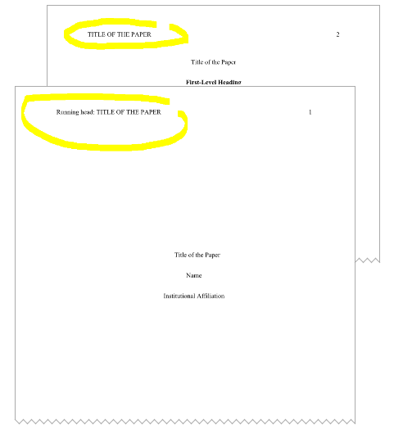

### Title page

1. The title should be centered on the page, typed in 12-point Times New Roman Font.
2. It should not be bolded, underlined, or italicized.
3. It should be in **title case**\*

Note

Title case means that all the notional parts of speech (verbs, nouns, pronouns, adjectives, and adverbs) and secondary parts of speech which are four letters long or longer should start with a capital letter. The first word in the title or the first word after the dash or the colon should always start with a capital letter.

1. The title should correspond to the topic of the paper and be reflected in the running head.
2. The author’s name and institution should be double spaced and centered.
3. They should not be bolded, underlined, or italicized.

Note

Sometimes, the customers request the topic to be per the writer’s choice. In such a situation, the writers should make the title on their own based on the topic revealed in the paper.

Moreover, very often the customers point out the subject to which the topic relates as a title of the paper (e.g. Sociology). It cannot be the title of the paper. The writers should also make the title on their own based on the topic revealed in the paper.

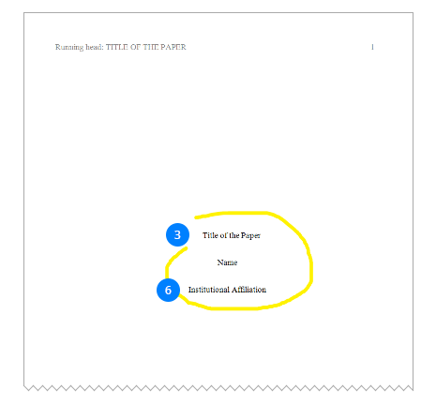

### Abstract

* The second page of the paper is dedicated to Abstract.
* In the abstract, the writers should briefly summarize the paper, which allows readers to quickly review its main points and purpose.
* The abstract should be between 150-250 words.
* Abbreviations and acronyms used in the paper as well as other keywords should be defined in the abstract.
* The word “Abstract” should be centered and typed in 12 point Times New Roman.
* It should not be bolded, underlined, or italicized.
* The first line of the abstract paragraph should be flush left (flush-left, or not indented, means that there should be no spacing before the first line of the paragraph).

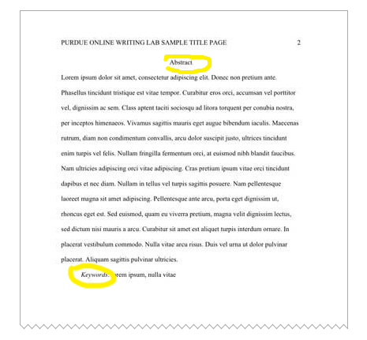

Note

Customers sometimes do not require the Abstract to be included into the papers. But please, make sure the writers insert it when they deal with more complicated orders, say University papers, research papers and so on.

### The page following the Abstract

* The page following the Abstract (or the second page if the Abstract is not required) should begin with the title of the paper, which should be centered on the page, typed in 12-point Times New Roman Font.
* It should not be bolded, underlined, or italicized.
* It should be in title case

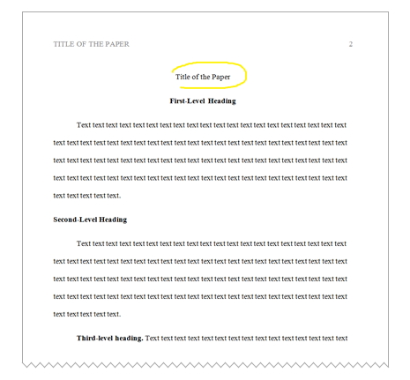

Note

Some writers erroneously regard the title of the paper as the heading of the 1st level. It is wrong. The title is just the title. It is neither the 1st level heading nor the A-level heading (according to another terminology). The same concerns Abstract and References.

### In-text citations

* APA format presupposes the author-date method of in-text citation: the author's last name and the year of publication for the source should appear in the text and a complete reference should appear in the References at the end of the paper.
* In-text citations that are direct quotes should include the author’s/ authors’ name/s, the publication year, and page number/s: (James, 2014, p. 150). Do not forget about the comma between the author’s last name and the year of publication and the period after ‘p.’
* If you are just paraphrasing a source, you only have to make reference to the author and year of publication and not the page number in your in-text reference: (James, 2014). Do not forget about the comma between the author’s name and the year of publication.
* As a rule, in-text citations are put at the end of the idea paraphrased:

Example

In Africa, beating the heat is largely done by using the most traditional means of shade and water (James, 2014).

Note

The period is put after the in-text citation.

* If **while paraphrasing the idea** the author’s name is mentioned in the text, only the year of publication is included into parenthesis which directly follows. No in-text citation is used in the end:

Example

According to James (2014), in Africa, beating the heat is largely done by using the most traditional means of shade and water.

* But if the author’s name is mentioned before he/she **is quoted directly**, the year of publication is included into parenthesis which directly follows and the page number is put in the parenthesis at the end of the quotation:

Example

According to James (2014), “In Africa, beating the heat is largely done by using the most traditional means of shade and water” (p.150).

* If the direct quotation is 40 words, or longer, it should be put in a free-standing block of lines. No quotation marks should be used.
* One should start the quotation from the new line, indented (in the same place one would begin a new paragraph). Each line which follows should be also indented as the first one. Double-spacing should be maintained. The parenthetical citation should come after the closing punctuation mark.

Example

James’s (2014) research founded the following:  
In Africa, beating the heat is largely done by using the most traditional means of shade and water. Shade comes mostly from trees - Johannesburg is known for having the largest man-made forest in the world with over 10 million trees planted across the city of gold. It is these trees that come in handy when it is very hot. People simply sit under the trees in the shade.

* When a print source has a corporate author, one may use the name of the corporation followed by the year for the in-text citation for the first time.
* If the organization has a well-known abbreviation, include the abbreviation in brackets the first time the source is cited and then use only the abbreviation in later citations.

First citation

(World Trade Organization [WTO], 2000)

Second citation

(WTO, 2000)

* When the author of the work is unknown, one should cite the source by its title in the signal phrase or use the first word or two in the parentheses.Titles of books and reports are italicized; titles of articles, chapters, and web pages are in quotation marks.

Example

(“Annual Marathon”, 2014).

* If no author or date is given, use the title in your signal phrase or the first word or two of the title in the parentheses and use the abbreviation "n.d." (for "no date").
* To cite multiple sources in the same parenthetical reference, separate the citations by a semicolon

Example

...as has been discussed elsewhere (James, 2014; Dewey, 2015).

### Reference to sources

While referring to the title of a source within the paper, **title case** should be used.

Example

A Darkness More Than Night

While using the title of a source in References, **sentence case** should be used.

Note

**Sentence case** means that only the first word, proper nouns and some other words alike should start with a capital letter.

Example

Connelly, M. (2001). A darkness more than night . NY: Little Brown and Company.

Remember how the titles of different sources should be formatted in the text:

|  |  |
| --- | --- |
| **Italicized** | **In quotation marks** |
| * books * edited collections * movies * television series * documentaries * albums | * journal articles * articles from edited collections * television series episodes * song titles |

### Reference to Author(s)

Please, remember how to refer to one or more authors in the text of the paper as well as in the parenthesis when they are mentioned for **the first time in the paper**:

|  |  |  |  |
| --- | --- | --- | --- |
| **Number of Authors** | **In the text of the paper** | **In the parenthesis** | **Comments** |
| Two Authors | According to James and Kameron (2014) | (James & Kameron, 2014) | & is called ampersand |
| Three to Five Authors | According to James, Brown, and Kameron (2014) | (James, Brown, & Kameron, 2014) | List all the authors Do not forget to put a comma before ‘and’ and before the ampersand |
| Six and more Authors | According to James et al. (2014) | (James et al., 2014) | Do not forget: period is put after ‘al.’ and not after ‘et’ |

Please, remember how to refer to one or more authors in the text of the paper as well as in the parenthesis when they are mentioned for **the second time in the paper and subsequently**:

|  |  |  |
| --- | --- | --- |
| **Number of Authors** | **In the text of the paper** | **In the parenthesis** |
| Two Authors | According to James and Kameron (2014) | (James & Kameron, 2014) |
| Three to Five Authors | According to James et al. (2014) | (James et al., 2014) |
| Six and more Authors | According to James et al. (2014) | (James et al., 2014) |

### Headings

In order not to be confused, for our company we have chosen **the numeric system** of defining the level of headings. So, further on, we will speak about 1st, 2nd, 3rd level headings and elude A, B, C level headings.

#### APA Headings

1. **1 level**: **Centered, Boldface, Title Case Headings**
2. **2 level**: **Left-aligned (= Flush left), Boldface, Title Case Heading**
3. **3 level**: **Indented, boldface, sentence case heading with a period**. Begin the text after the period.
4. **4 level**: **Indented, boldface, italicized, sentence case heading with a period**. Begin the text after the period.
5. **5 level**: Indented, italicized, sentence case heading with a period. Begin body text after the period.

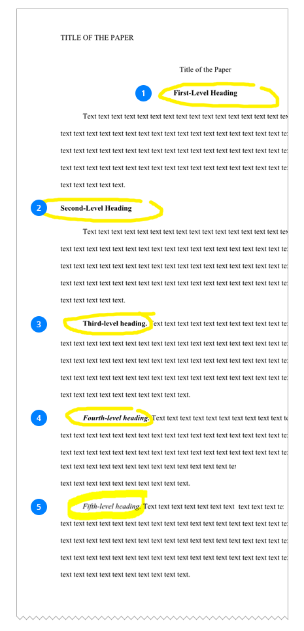

Note

\***flush left** means that the heading is on the left and there is no spacing before it

\***indented** means that the heading is on the left but there is some spacing before it (as a rule, 05’’ which equals to 1.27 cm)

### References

1. The list of sources used in the paper should appear at the end of the paper.
2. It should begin on a new page separate from the text of the essay.
3. It should be labelled ‘References’ (without any other variants; and if only one source is used, it should be in plural anyway)
4. The word ‘References’ should be centered at the top of the page (NOT bolded, not underlined, not italicized, not in quotation marks).
5. All lines after the first line of each entry in the list should be indented one-half inch from the left margin. This is called hanging indentation.
6. Double-space all entries.
7. Authors' names are inverted (last name first); give the last name and initials for all authors of a particular work for up to and including seven authors. If the work has more than seven authors, list the first six authors and then use ellipses after the sixth author's name. After the ellipses, list the last author's name of the work.
8. References should be arranged in the alphabetical order.
9. Remember that the titles of books and periodicals are italicized in the References as a rule.
10. The articles or the chapters are not italicized. No quotation marks for them.
11. For the titles of books the **sentence case** should be used.
12. For the titles of periodicals the **title case** should be used.
13. For the online sources, the word Retrieved is used (without any other variants). The exception is when the writer uses the electronic book which is not directly available online or must be purchased. In this case ‘Available from’ is more logical than ‘Retrieved from’.

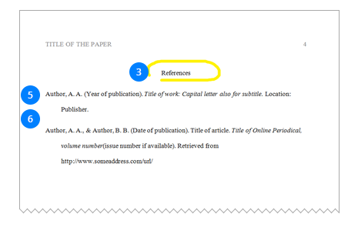

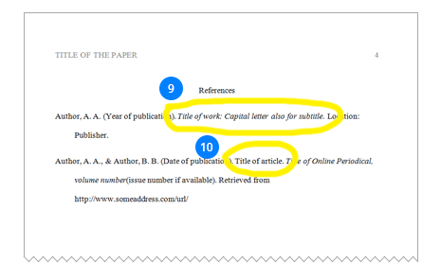

Note

Since the aim of this presentation is to stress the most typical features of APA and MLA formatting styles, in particular, those where the writers often make mistakes, we do not provide information about how each type of source should be formatted in the References.

For more details, please, see the [Citation Style Chart](https://drive.google.com/file/d/0Byco6UmWPVkAeHVqdU5sNTJ5WUE/view?usp=sharing).

### Title Case and Sentence Case Capitalization in APA

Let’s resume what is the difference between the title case and the sentence case and when they should be used in the APA.

**Title case** refers to a capitalization style in which most words are capitalized, and **sentence case** refers to a capitalization style in which most words are lowercased. In both cases, proper nouns and certain other types of words are always capitalized.

#### Title Case

Title case is used to capitalize the following types of titles and headings in APA Style:

* Titles of references (e.g., book titles, article titles) when they appear in the text of a paper
* Titles of inventories or tests
* Headings at Levels 1 and 2
* The title of your own paper and of named sections within it (e.g., the Discussion section), and
* Titles of periodicals (journals, magazines, or newspapers), which are also italicized (e.g., Journal of Counseling Psychology, The New York Times).

**Directions for implementing APA’s title case:**

1. Capitalize the first word of the title/heading and of any subtitle/subheading;
2. Capitalize all “major” words (nouns, verbs, adjectives, adverbs, and pronouns) in the title/heading, including the second part of hyphenated major words (e.g., Self-Report not Self-report); and
3. Capitalize all words of four letters or more.

This boils down to using lowercase only for “minor” words of three letters or fewer, namely, for conjunctions (words like and, or, nor, and but), articles (the words a, an, and the), and prepositions (words like as, at, by, for, in, of, on, per, and to), as long as they aren’t the first word in a title or subtitle.

#### Sentence case

Sentence case is used in a few different contexts in APA Style, including for the following:

* The titles of references when they appear in reference list entries and
* Headings at Levels 3, 4, and 5
* Here are directions for implementing sentence case in APA Style in these two contexts:
  1. Capitalize the first word of the title/heading and of any subtitle/subheading;
  2. Capitalize any proper nouns and certain other types of words;
  3. Use lowercase for everything else.

Here are some examples of different types of (capitalized) proper nouns, along with some (lowercased) regular or common noun corollaries:

|  |  |  |
| --- | --- | --- |
| **Noun type** | **Proper noun example** | **Common noun example** |
| Author or person | Freud, Skinner, von Neumann | the author, the investigator, the scientist |
| Company, institution, or agency | American Psychological Association, University of Washington, Department of Sociology | the association, a university, a sociology department |
| Product | Advil, Xerox, Prozac (brand names) | ibuprofen, photocopy, fluoxetine (generic names) |
| Test or inventory | Beck Depression Inventory, Child Behavior Checklist | a depression inventory, a behavior checklist |
| Website or database | PsycINFO, Facebook, Survey Monkey, Internet | a database, a social media page, a website, online |
| Periodical (journal, magazine, newspaper) | Journal of Counseling Psychology, Time, The Washington Post | a psychology journal, a magazine, a newspaper |
| Software, program, or app | SPSS, Mplus, Davis’s Drug Guide for iPhone | statistical software, a computer program, a mobile app drug guide |
| Legal materials (statutes, acts, codes, bills, regulations, constitutions, etc.) | Americans With Disabilities Act, FDA Prescription Drug Advertising Rule, U.S. Constitution | antidiscrimination laws, drug advertising legislation, a constitution |
| Most nouns when they are followed by numerals or letters | Table 1, Figure 2, Panel A | if they are not followed by the numerals or letters: table, figure, panel |

Let’s sum up how different types of sources should be formatted in APA. The following table summarises what font and case should be used for the longer works and for their parts in the text of the paper and in References.

|  |  |  |
| --- | --- | --- |
| **Type of the Source** | **In the text** | **In References** |
| Book Title | italicized, title case | italicized, sentence case |
| Title of the Periodical | italicized, title case | italicized, title case |
| Book Chapter | in quotation marks, title case | not italicized, not in quotation marks, sentence case |
| Article in Periodical | in quotation marks, title case | not italicized, not in quotation marks, sentence case |

### Summing Up…

#### Basic Features of APA

**Running head** is present on each page

**Title page** contains only three pieces of information: Title of the Paper, Name, Institution

The second page is dedicated to **Abstract**

**The page following the Abstract** starts with a title of the paper

**In-text citations** usually contain information about the author of the work and the year of publication. Comma is necessary between them (James, 2014)

**The headings** are strictly levelled.

The word **‘References’** is used for the list of sources.

To better understand the main principles of APA formatting, please, also download the [**APA sample**](https://drive.google.com/file/d/0Byco6UmWPVkAejFmZHZNaG04UTg/view?usp=sharing).

## MLA Formatting Style

MLA (Modern Language Association) style, which is used to write papers and cite sources within the liberal arts and humanities

### First page

1. In MLA, there has to be a writer’s surname and a page number in the right upper corner of each page. This header has to be flush right.
2. There is no title page in MLA. The paper begins with a section on the left which contains information about the student’s name, the professor’s name, the course number, and the date of the paper. Do not violate this order!
3. This section should be flush left, double-spaced.
4. Begin the title of the paper from the next line.
5. It has to be centered, not underlined, not italicized, not placed in quotation marks (unless you refer to other works in your title such as books, articles, films etc.).
6. The Title Case has to be used for the title.

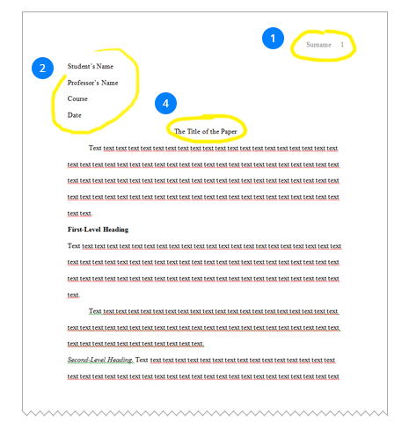

Note

Sometimes the customers may require a single spacing. Then you should follow the requirements. Or they may request for a title page. In such situation, they should provide you with clarifications on how the title page should look like. If not, ask for them. Do not forget about the terms of proper communication between writers and customers which you have had a chance to learn in one of our previous presentations.

### In-text citations

* In-text citations in MLA contain information about the author of the work and the page number with **no comma between them**.
* As a rule, in-text citations are put at the end of the idea paraphrased:

Example

In Africa, beating the heat is largely done by using the most traditional means of shade and water (James 150).

Note

The period is put after the in-text citation.

* If **while paraphrasing the idea** the author’s name is mentioned in the text, only the page number is included into parenthesis which is located **at the end of the idea paraphrased**.

Example

According to James, in Africa, beating the heat is largely done by using the most traditional means of shade and water (150).

* Use block quotes when quotations are longer than four typed lines.
* Block quotes begin on a new line, are double spaced, and are indented 1” from the margin. Do not use quotation marks.The citation information (either the author name and the page number or just the page number) **follows the punctuation mark which is at the end of the quotation**.

Example

James’s research founded the following:  
In Africa, beating the heat is largely done by using the most traditional means of shade and water. Shade comes mostly from trees - Johannesburg is known for having the largest man-made forest in the world with over 10 million trees planted across the city of gold. It is these trees that come in handy when it is very hot. People simply sit under the trees in the shade. Water is another way of cooling down on a hot summer's day. In South Africa people tend to spend time in swimming pools either at home or in publicly run pools. There are also the ice lollies sold at traffic lights. (150)

* When a print source has a corporate author, one may use the name of the corporation followed by the page number for the in-text citation.
* When the author of the work is unknown, one should use a shortened title of the work instead of an author’s name. The title should be placed in quotation marks if it's a short work (e.g. an article) or italicized if it's a longer work (e.g. plays, books, television shows). Besides, the page number is to be provided.

Example

(“Annual Marathon” 45).

Note

The full name of the article should appear first at the left-hand margin of its respective entry in the Works Cited

Example

“Annual Marathon.” Sport Today. 2014, http://www.bbc.co.uk/programmes/p00lmvvy.Accessed 4 May 2009.

* To cite multiple sources in the same parenthetical reference, separate the citations by a semicolon

Example

...as has been discussed elsewhere (James 3; Dewey 21).

* If you are citing non-print sources without page numbers available, include in **the first item** that appears in the Work Cited entry that corresponds to the citation (e.g. author’s name, article name, website name, film name) either to the text (then no parenthesis is needed at all) or to the parenthesis.

Example

During the presentation, Jane Yates stated that invention and pre-writing are areas of rhetoric that need more attention.

OR

Example

In the presentation it was stated that invention and pre-writing are areas of rhetoric that need more attention (Yates).

The respective entry on the Works Cited page is the following:  
Yates, Jane. "Invention in Rhetoric and Composition." Gaps Addressed: Future Work in Rhetoric and Composition, CCCC, Palmer House Hilton, 2002. Presentation.

### Reference to sources

In MLA, unlike APA, both in the text of the paper and in the Works Cited, **title case** is used to refer to some particular sources.

Examples

**In the text**: A Darkness More Than Night

**In the Works Cited**: Connelly, Michael. A Darkness More than Night. Little Brown and Company, 2001.

But as well as in the APA, longer works are usually italicized, whereas parts of works are put in quotation marks.

### Reference to Author(s)

If two or more authors have the same last name, provide both authors' first initials.

Example

Whereas some specialists suggest beating the heat using shade and water (R. James 150), others are for some more radical means (P. James 78).

In MLA, unlike APA, there is no difference whether the reference to the author(s) is made for the first or for the second time. Neither is any difference between the reference to the author(s) in the text of the paper and the parenthesis:

|  |  |  |  |
| --- | --- | --- | --- |
| **Number of Authors** | **In the text of the paper** | **In the parenthesis** | **Comments** |
| Two Authors | According to James and Kameron, ... (150). | (James and Kameron 150) | Do not forget that a page number in the parenthesis should be in the end |
| Three and more Authors | According to James et al., ... (150) | (James et al. 150) | 1) Period is put after ‘al.’ and not after ‘et’ 2) In the Works Cited, mention all authors with the comma before ‘and’ |

### Headings

As was mentioned, in our company we will stick to the numeric system of headings for all formatting styles (1st, 2nd, 3rd…).

Unlike APA, there are no strict rules at to how each level heading should be formatted.Therefore, for our company, we have chosen the following system of headings in MLA each writer should stick to unless not followed by particular instructions of the customer:

#### MLA headings

1. **1 level**: **Bold, Flush Left, Title Case**. The paragraph should start from a new line, also flush left.
2. **2 level**: Italics, Flush Left, Title Case. The text should begin just after the period.
3. **3 level**: **Centered, Bold, Title Case**. The paragraph should start from a new line, flush left.
4. **4 level**: Centered, Italics, Title Case. The paragraph should start from a new line, flush left.
5. **5 level**: Underlined, Flush Left, Title Case. The paragraph should start from a new line, also flush left.

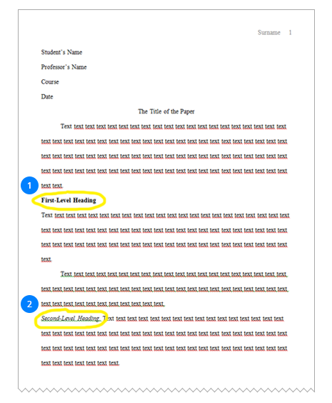

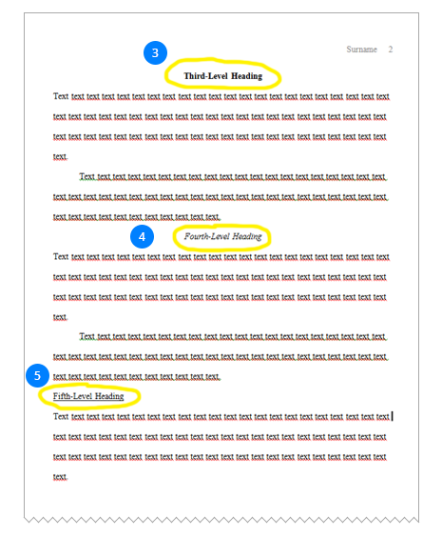

### Works Cited

1. The list of sources used in the paper should appear at the end of the paper.
2. It should begin on a new page separate from the text of the essay.
3. It should be labelled ‘Works Cited’ (both words should start with a capital letter; if only one source is used, you may use ‘Work Cited’ in singular).
4. The words ‘Works Cited’ should be centered at the top of the page (NOT bolded, not underlined, not italicized, not in quotation marks).
5. Double space all citations, but do not skip spaces between entries.
6. Indent the second and subsequent lines of citations by 0.5 inches to create a hanging indent.
7. Sources should be arranged in the alphabetical order by the the author's last name. Authors' names are written last name first; middle names or middle initials follow the first name. Unlike in APA, please, try to provide full names instead of initials.
8. If the author of the work is unknown, alphabetize it by its title **but together with all other sources**.

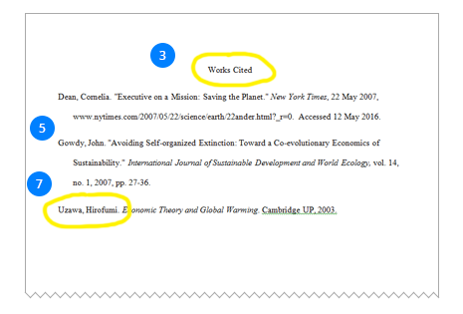

#### A print book with one author:

Jacobs, Alan. The Pleasures of Reading in an Age of Distraction. Oxford UP, 2011.

Only the most essential information is included (author’s name, book title, publisher, and date). Note that the city of publication is not needed, and the medium of publication is eliminated.

#### An article from a scholarly journal:

Kincaid, Jamaica. “In History.” Callaloo, vol. 24, no. 2, Spring 2001, pp. 620-26.

This version identifies the volume (24), the number (2), and the page numbers (620-26) of the scholarly journal. Also note that punctuation is simple; only commas separate the journal title, volume, number, date, and page numbers.

#### Online Sources:

Bernstein, Mark. "10 Tips on Writing the Living Web." A List Apart: For People Who Make Websites, 16 Aug. 2002, alistapart.com/article/writeliving. Accessed 4 May 2009.

For online sources, you should include a location to show readers where you found the source. Many scholarly databases use a DOI (digital object identifier). Use a DOI in your citation if you can; otherwise use a URL. Delete “http://” from URLs. The DOI or URL is usually the last element in a citation and should be followed by a period.

All works cited entries end with a period.

MLA also uses the phrase, “Accessed on” to denote which date you accessed the web page when available or necessary.

#### A YouTube Video

With the Eighth edition you may now cite YouTube.

Video and audio sources need to be documented using the same basic guidelines for citing print sources in MLA style. Include as much descriptive information as necessary to help readers understand the type and nature of the source you are citing. If the author’s name is the same as the uploader, only cite the author once. If the author is different from the uploaded, cite the author’s name before the title.

“8 Hot Dog Gadgets put to the Test.” YouTube, uploaded by Crazy Russian Hacker, 6 Jun. 2016, www.youtube.com/watch?v=WBlpjSEtELs.

McGonigal, Jane. “Gaming and Productivity.” YouTube, uploaded by Big Think, 3 July 2012, www.youtube.com/watch?v=mkdzy9bWW3E.

1. You do not have to put ‘Print’ for print sources according to the 8th edition of the MLA guide.
2. Instead of Web for online sources, use Accessed on.
3. You should use a DOI in your citation if you can; otherwise use a URL.
4. Delete “http://” from URLs. The DOI or URL is usually the last element in a Citation and should be followed by a period.

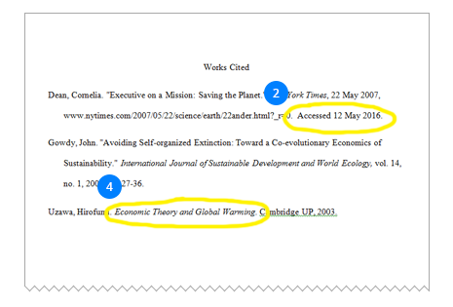

Remember that the titles of books and periodicals are italicized in the Works Cited as a rule.

The articles or the chapters are not italicized. Use quotation marks for them.

Unlike in APA, the title case should be used **for all sources**. So, capitalize each word except articles (the, a, an), prepositions, or conjunctions unless one is the first word of the title or subtitle.

Let’s sum up how different types of sources should be formatted in MLA in the text of the paper and in Works Cited.

|  |  |  |
| --- | --- | --- |
| **Type of the Source** | **In the text** | **In References** |
| Book Title | italicized, title case | italicized, title case |
| Title of the Periodical | italicized, title case | italicized, title case |
| Book Chapter | in quotation marks, title case | in quotation marks, title case |
| Article in Periodical | in quotation marks, title case | in quotation marks, title case |

### Summing Up…

#### Basic Features of MLA

**Double spacing** is used throughout the whole paper

There is **no title page** as a rule

There is a **Header** in the upper right-hand corner of each page where **Surname and page number** are mentioned

There is a section on the left of **the first page** with the student’s name, the professor’s name, the course number, and the date of the paper

**In-text citations** usually contain information about the author of the work and the page number with no comma between them

**The headings** are levelled

The words **‘Works Cited’** are used for the list of sources

To better understand the main principles of MLA formatting, please, also download the

# Chicago Formatting Style

The Chicago Manual of Style presents two basic documentation systems: (1) notes and bibliography and (2) author-date. This presentation is dedicated to the first system since it is more often used in our company.

### General Points

* Chicago style is recommended for the papers in the humanities and some social sciences.
* Margins should be set at 1”.
* The font should be Times New Roman.
* Font size should be 12 pt.
* Text should be double-spaced. The exceptions are block quotations, table titles, and figure captions, which should be single-spaced.
* Notes and bibliographies should be singled-spaced internally; however, leave an extra line space between note and bibliographic entries.
* Page numbers begin in the header of the first page (not the title page) with Arabic number 1, flush right.
* If there is no title page, just place a page number on the first page.

### Title Page

1. There is no page number on the title page.
2. The title should be centered a third of the way down the page. Divide your page into three parts and type in the title below the upper one-third of the paper.
3. The title should be in CAPS.
4. If there is a subtitle, end the title line with a colon and place the subtitle on the line below the title. Subtitle should also be in CAPS.
5. Type in the student’s name, class information and the date of the paper below the middle one-third of the paper. Do not include any other information unless it is required by the customer.

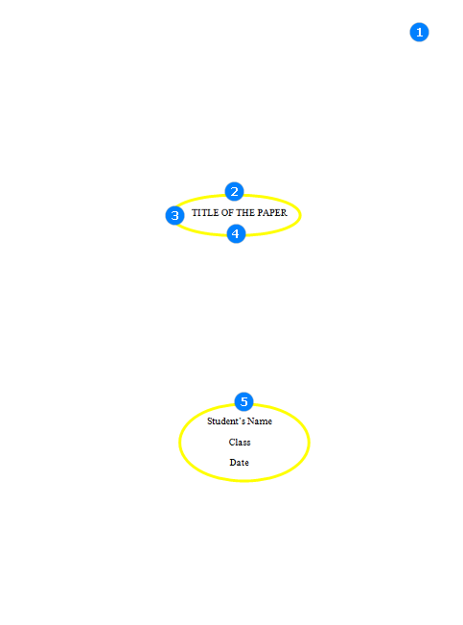

Note: Sometimes, the title page is not required by the customer. In such a case, include the title on the first page of the text, in CAPS.

### First Page

1. Arabic page numbers begin in the header of the first page of text, flush right.
2. If there is a title page, do not duplicate the title of the paper on the first page.
3. Just begin the text of the paper with a new line, indented 0.5”.

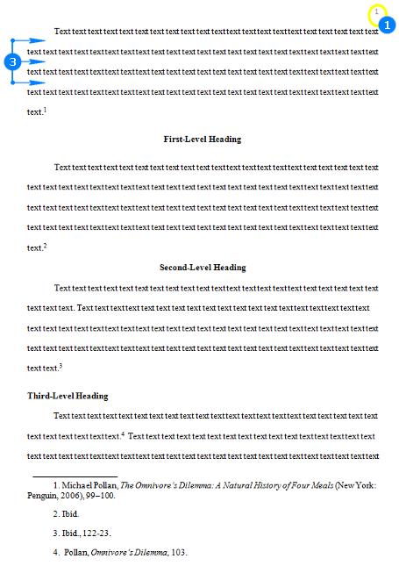

Note: Please, do not mix the title page with the first page.

### Footnotes

1. Chicago requires using notes to cite sources and/or providing relevant commentary.
2. You should include a footnote each time you use a source, no matter whether you quote the author directly or just paraphrase.
3. Footnotes should be added at the end of the page on which the source is referenced, and endnotes are to be listed at the end of each chapter or at the end of the entire document.
4. Note numbers should be placed at the end of the clause or sentence to which they refer and should be placed after any punctuation mark except the dash.
5. Note numbers should begin with “1” and follow consecutively throughout a given paper, article, or chapter.
6. In the text, note numbers are superscripted.To make the number superscript, select it and on the Home tab, in the Font group, click Superscript. Or press CTRL+SHIFT+=.  
   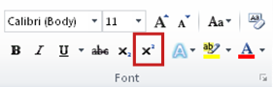

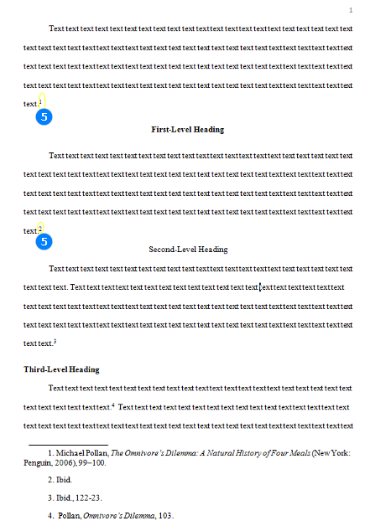

1. In the notes themselves, note numbers are full sized (not raised) and followed by a period and a space.
2. The first line of a footnote is indented 0.5” from the left margin (=1.27 cm).
3. Subsequent lines within a footnote should be formatted flush left.
4. Leave an extra line space between footnotes.
5. Place commentary after documentation if needed separated by a period.
6. The first note for each source should include all relevant information about the source.
7. If you cite the same source somewhere in the paper again (but not consecutively), the note should include only the surname of the author followed by a comma (,), a shortened form of the title (if more than four words) followed by a comma (,), and page number(s).Do not forget to put a period after it.
8. If you cite the same source and page number(s) from a single source two or more times consecutively, the corresponding note should use the word “Ibid.” Do not forget to put a period after it.
9. If you use the same source but a different page number, the corresponding note should use “Ibid.” followed by a comma (,) and the new page number(s). Do not forget to put a period after it.
10. When a page range is cited, the hundreds digit need not be repeated if it does not change from the beginning to the end of the range (e.g. 122-23). See the example marked orange on the reenshot.

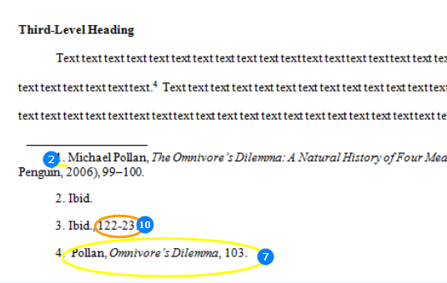

* If you cite a book, the note (for the first time) should include the following information: author’s full name (not inverted) followed by a comma (,), book title (italicized, title case), facts of publication (in parentheses), and page number (s).
* Facts of publication include the city of publication followed by a colon (:), a publisher followed by a comma (,), and a year of publication.
* Do not forget to put a period at the end of the note.

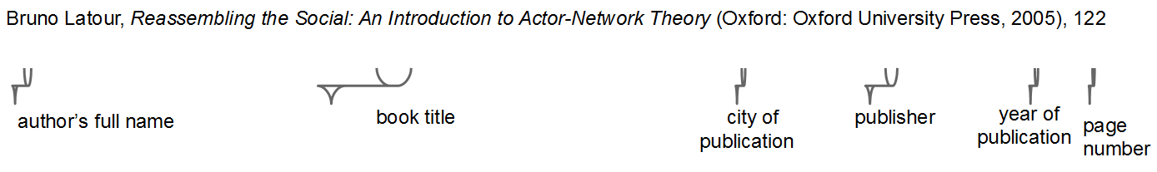

* Pay attention: when a page range is cited, the hundreds digit (if any) does not have to be repeated.

https://www.uvocorp.com/img/common/writing_giudes_img/chicago-footnotes-4.png

* For online books, just add the URL after facts of publication instead of page number(s).
* If you cite a periodical, the note (for the first time) should include the following information: author’s full name (not inverted) followed by a comma (,), article title in quotation marks, title case, followed by a comma (,), journal title (italicized, title case) and issue information.
* Issue information refers to volume, which follows the journal title with no punctuation and is not italicized, issue number preceded by “no.’’ The year appears in parenthesis after the volume number (or issue number if given) and is followed by a colon (:). The year may be preceded by a specific date, month, or season if given. Page information follows the year.

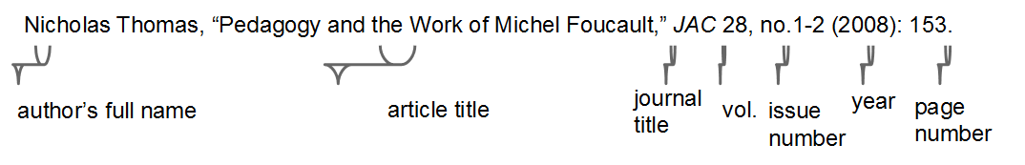

* If you use an electronic book, just add the URL instead of the page number(s)

Example:

Philip B. Kurland and Ralph Lerner, eds., The Founders’ Constitution (Chicago: University of Chicago Press, 1987), http://press-pubs.uchicago.edu/founders/.

* For online periodical, just add the URL or DOI

Example:

Gueorgi Kossinets and Duncan J. Watts, “Origins of Homophily in an Evolving Social Network,” American Journal of Sociology 115 (2009): 411, doi:10.1086/599247.

Note: if the date of access to the source is required, you should add accessed (date) before the URL.

* If you cite the whole website, the note should look in the following way:

Firstname Lastname (if any), “Title of Web Page,” Publishing Organization or Name of Website in Italics, publication date and/or access date if available, URL.

Example:

“McDonald’s Happy Meal Toy Safety Facts,” McDonald’s Corporation, accessed July 19, 2008, http://www.mcdonalds.com/corp/about/factsheets.html.

Note: The next note in this case will consist only of the title of the website

* If the author of the work is unknown, cite the source by the title just omitting the author at the beginning of the note.

Example:

Reassembling the Social: An Introduction to Actor-Network Theory (Oxford: Oxford University Press, 2005), 122

* When an editor’s or translator’s name appears in addition to an author’s, it should be also included into a note and bibliography at the end of the paper (in the latter it appears as **Edited by** or **Translated by**.
* In the note it appears shortened to **ed.** and **trans.** after a title followed by a comma (,).

Example:

Gabriel García Márquez, Love in the Time of Cholera, trans. Edith Grossman (London: Cape, 1988), 242–55.

* If you use a part of the work (e.g. chapter of a book), in the note, mention it after the author’s name and put it in quotation marks. Use the preposition ‘in’ to mark the source this part belongs to.

Example:

John D. Kelly, “Seeing Red: Mao Fetishism, Pax Americana, and the Moral Economy of War,” in Anthropology and Global Counterinsurgency (Chicago: University of Chicago Press, 2010), 77.

### Long quotations

* A prose quotation of five or more lines should be “blocked.”
* The block quotation is single spaced and takes no quotation marks.
* You should leave an extra line space immediately before and after.
* Indent the **entire** quotation 0.5” (the same as you would the start of a new paragraph).

Example:

In the article A Long Way to Sobriety Ella Jameson states:

Young adults are more susceptible to addiction than ever before. Many illicit substances such as alcohol and prescription medication are far more easily accessible than previously, and possession of these substances is also more socially acceptable. Many teens and young adults who begin experimenting with illicit substances don’t intend to develop an addiction, but experimentation can quickly lead users down a dangerous road.1

### Reference to Authors

Please, pay attention how one, two and more authors should be mentioned in the text, in the note and in the Bibliography.

Number of AuthorsIn the textIn the noteIn the BibliographyComments

| **Number of Authors** | **In the text** | **In the note** | **In the Bibliography** | **Comments** |
| --- | --- | --- | --- | --- |
| One Author | Burns | Ken Burns | Burns, Ken | do not forget to put a comma between a last name and a first name in the bibliography |
| Two and Three Authors | Ward and Burns | Geoffrey C. Ward and Ken Burns | Ward, Geoffrey C., and Ken Burns | the name of the first author is inverted in the bibliography; the name of the second is not; do not forget to put a comma before ‘and’ in the bibliography |
| Four and more Authors | Barnes et al. | Dana Barnes et al. | Barnes, Dana, G.C. Ward, K. Burns, and C. R. Sun | list all of the authors in the bibliography; in the note and in the text, list only the first author, followed by et al.only the first name is inverted |

### Reference to Sources

Remember how the titles of different sources should be formatted in Chicago:

**Italicized**

* books
* edited collections
* movies
* television series
* documentaries
* albums

**In quotation marks**

* journal articles
* articles from edited collections
* television series episodes
* song titles

Note:

In Chicago, this rule is applicable to the sources no matter where they are mentioned: in the text, in the note or in the Bibliography. Besides, please, mind that **title case** is used for all the sources no matter where they are located.

### Endnotes

* Chicago also allows for a system of “endnotes.”
* Endnotes may become useful when footnotes consume a lot of space and/or extend beyond the page to which they refer.
* Endnotes appear at the end of a paper, article, or chapter (after the text before the bibliography) with a page title of “Notes.”
* Using endnotes, put note numbers at the end of the clause or sentence to which they refer and add a corresponding note to the Notes page.
* Endnotes are formatted in the same way as the footnotes.

Note:

as a rule, we use footnotes unless followed by particular customer’s requirements..

### Headings

Since Chicago has an optional system of five heading levels, we have worked out our own system of headings we will use in our company. Please, stick to it:

#### Chicago Headings

1. **1 st level: Centered, Boldface, Title Case**

The paragraph begins from a new line, indented.

1. **2nd level: Centered, Not Bolded, Title Case**

The paragraph begins from a new line, indented.

1. **3 rd level: Flush Left, Boldface, Title Case**

The paragraph begins from a new line, indented

1. **4 th level: Flush left, not bolded, sentence case**

The paragraph begins from a new line, indented

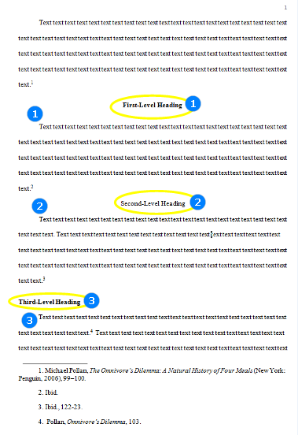

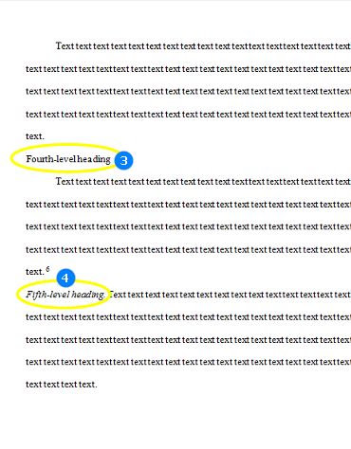

### Tables and Figures

1. Place tables and figures after the paragraph where they’re described.
2. Cite the source of the table and figure information with a “source line” at the bottom of the table or figure. Source lines are introduced by the word Source(s), followed by a colon, author’s last name and year of publication, followed by a comma, and the page number, ended with a period.
3. But the full information about the source should be included into the corresponding entry in Bibliography.
4. Every table should have a number and (a short and descriptive) title flush left on the line above the table.
5. Every figure should have a number and a caption flush left on the line below the figure.
6. Number tables and figures separately in the order you mention them in the text.
7. In the text, identify tables and figures by number (“in figure 3”) rather than by location (“below”).
8. Table titles, and figure captions, which should be single-spaced. Use the title case capitalization.

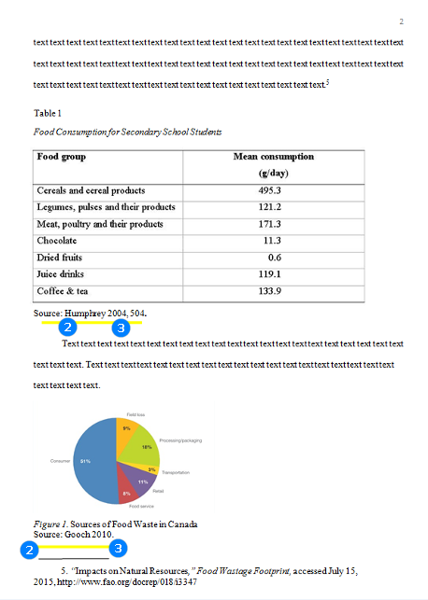

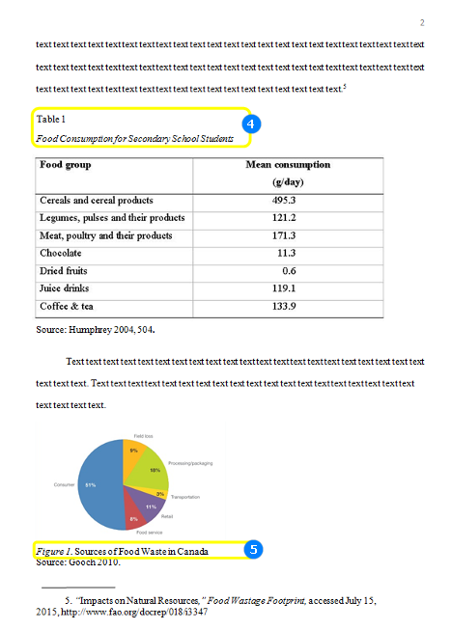

### Bibliography

1. The list of sources used in the paper should appear at the end of the paper.
2. It should begin on a new page separate from the text of the essay.
3. In Chicago Citation Style, we name the list of sources ‘Bibliography’.
4. The word ‘Bibliography’ should be centered at the top of the page (NOT bolded, not underlined, not italicized, not in quotation marks).
5. The first line of each entry should be flush left. All lines after the first line of each entry in the list should be indented one-half inch from the left margin (hanging indentation).
6. There should be two blank lines between “Bibliography” and the first entry.
7. There should be one blank line between remaining entries.
8. Lines within the bibliography entries should be singled-spaced internally; however, you should leave an extra line space between the bibliographic entries.
9. Entries should be arranged in the alphabetical order according to the first word in each entry. As a rule, it is the author’s last name. If no author or editor is listed, the title or keyword by which the reader would search for the source may be used instead.
10. The author’s name is inverted in the bibliography. Place the last name first and separate the last name and first name with a comma.
11. Use “and,” not an ampersand, “&,” for multi-author entries.
12. The 3-em dash (—) should be used to replace authors or editors’ names who hold multiple, successive entries in a bibliography.
13. As a rule, the year of publication is mentioned at the end of the entry.
14. In the Bibliography, all major elements are separated by periods (whereas in notes, all major elements are usually separated by commas).
15. In Bibliography, in the text of the paper and in the notes, titles of books and journals are italicized. Titles of articles, poems, chapters, poems, etc. are placed in quotation marks.
16. The title case is used for all the titles in the Bibliography.

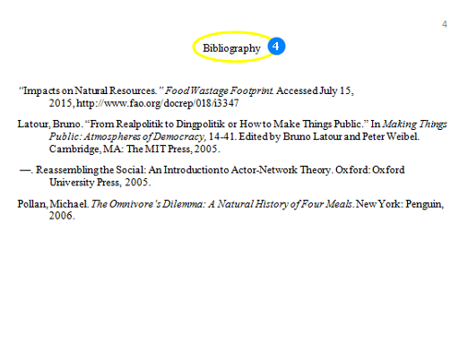

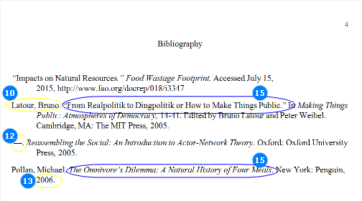

### Summing Up…

#### Basic Features of Chicago

* Page number starts with the first page, not the title page.
* The title of the paper is in CAPS.
* There is no title on the first page as a rule.
* Chicago presupposes the use of footnotes or endnotes. Note numbers should be placed at the end of the clause or sentence to which they refer. Footnotes should be added at the end of the page on which the source is referenced.
* The list of sources is labelled ‘Bibliography’.
* The formatting of footnotes and entries in the Bibliography differ: author’s name is not inverted in the footnotes but is inverted in the Bibliography.
* In the Bibliography, all major elements are separated by periods whereas in notes, all major elements are usually separated by commas.
* Headings of the 1st, 2nd and 3rd level are formatted using the title case. Headings of the 4th and 5th level are formatted using the sentence case.
* All titles in Chicago are formatted using the title case.
* Longer works (books, journals, movies) are italicized and parts of works (book chapters, articles) are in quotation marks in the text, in the notes and in the Bibliography in Chicago.

## Harvard Formatting Style

The Harvard style does not have a manual and there are various versions that are followed. That is why we have worked out our own guide that we will all stick to in our company.

### General Points

* Harvard is very similar to APA. Where APA is primarily used in the USA, Harvard referencing is the most well used referencing style in the UK and Australia, and is encouraged for use with the humanities.
* Like APA, Harvard presupposes using author name/date system when citing books, articles and other documents.
* Margins should be set at 1”.
* The font should be Times New Roman (Arial is also possible).
* Font size should be 12 pt.
* Text should be double-spaced.
* The header contains a short description of the title with the sequential page number and is placed flush left on each page.

### Title Page

1. Harvard formatting requires a very specific title page.
2. The header contains a short description of the title and a sequential page number (1). It should be present on each page.  
   e.g. If the title of the paper is ‘Colonization of Western Lands in the 17th century’, the header can be just ‘Colonization’.
3. The header is placed flush right. Between the partial title and the number are **exactly five spaces**.
4. About halfway down the page is the title of the paper, in CAPS.
5. About three lines down the title is the student’s name, not in capital letters.
6. Four lines down is the name of the course, and, on the line after that, the name of the professor. Next line is the name of the university (school), then the city and state where it is located (for the USA), and, finally the date.

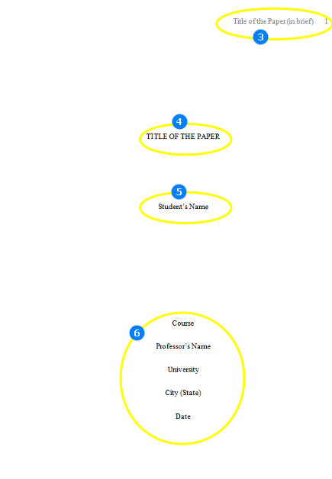

Note: Be very attentive to the customer’s instructions. If the latter requires another format, follow it.

### First Page

1. The header of the first page should contain the page number 2.
2. Like in APA, this page should begin with the title of the paper.
3. It should be centered, not in CAPS, not bolded, not underlined or italicized.
4. It should be in **title case**.

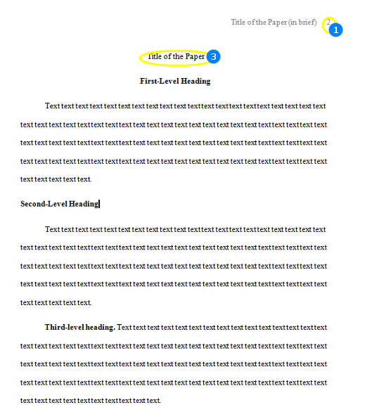

### In-text citations

* Harvard is an 'author/date' system, so the author's last name and the year of publication for the source should be stated in the text and a complete reference should appear in the reference list at the end of the paper.
* You should provide a citation for each fact, summary, paraphrase, or quotation you use from an outside source. If you don’t do this, it is plagiarism.
* Unlike in APA, there is no comma between the author’s name and the year of publication in the in-text citation.

Example:

(Clark 2006)

Note: In-text citations that are direct quotes should include the author’s/ authors’ name/s, the publication year, and page number/s.

* In-text citations are put just after the author or the author’s work is mentioned:

Example:

... a recent study (Smith 2009) has described ....

* If **while paraphrasing the idea** the author’s name is mentioned in the text, only the year of publication is included into parenthesis which directly follows.

Example:

According to Smith (2009), …

* If the author’s name is mentioned before he/she **is quoted directly**, the year of publication and the page number are included into parenthesis which directly follows

Example:

This statement is substantiated by Smith (2009, p.6) in his report…

* If the direct quotation is more than 30 words, it should be put in a free-standing block of lines. No quotation marks should be used. One should start the quotation from the new line, indented (in the same place one would begin a new paragraph). Each line which follows should be also indented as the first one. Double-spacing should be maintained. The parenthetical citation should come after the closing punctuation mark.

Example:

It was stated that:  
If any similar qualitative research is to be undertaken in the future, then stringent controls should be put in place to ensure such statistical anomalies do not occur through lack of methodological rigor, particularly through corruption of data inadequately stored and processes (Mullane 2006, p.66).

Note: The actual quote can be in slightly smaller font to distinguish it from the surrounding text.

* When a print source has a corporate author, one may use the name of the corporation followed by the year for the in-text citation for the first time.
* If the organization has a well-known abbreviation, include the abbreviation in brackets the first time the source is cited and then use only the abbreviation in later citations.

First citation:

(World Trade Organization [WTO] 2000)

Second citation:

(WTO 2000)

* When the author of the work is unknown, one should cite the source by its title.Titles of books are **neither in quotation marks nor italicized** in the parenthesis. However, they are italicized in the text. Titles of the chapters or articles are **in quotation marks**. Sentence case should be used for in-text citations.

Example:

(A history of Greece 1994)

* To cite multiple sources in the same parenthetical reference, separate the citations by a semicolon

Example:

... as has been discussed elsewhere (James 2014; Dewey 2015).

* To cite different sources of the same author and year, use letters ‘a’, ‘b’.

Example:

(Clark 2014a) (Clark 2014b)

* When the journal article is available only online and there is neither volume nor page numbers available, apart from the author’s name and the year, cite the title of the article and use the abbreviation "para." followed by the paragraph number.

Example:

(Bustamante 2014, ‘Public library of Cincinnati’, para. 4).

Note:

Mind the use of commas in the in-text citation

* When you cite the entire website, use its title (the title is in the title case as a rule) and the year in the parenthesis.

Example:

(Australian Securities Exchange 2009)

* When you cite the webpage which contains no author, use first few words of the page title (in the sentence case) and the year in the parenthesis.

Example:

(Improve indigenous housing 2007)

* When you cite the webpage with no available year, mention the author’s name followed by the abbreviation ‘n.d.’

Example:

(Jones n.d.)

### Reference to Sources

While referring to the title of a source within the paper and in the list of references, **sentence case** is used.

Exceptions:

* As a rule, the entire website is in the title case both within the paper and in the list of references.
* The title of a journal is in the title case both within the paper and in the list of references (please, do not mix with the title of the article, which is in sentence case).

### Reference to Author(s)

Please, remember how to refer to one or more authors in the text of the paper, in the parenthesis and in the list of references:

Number of AuthorsIn the text of the paperIn the parenthesisIn the Reference List

| One Author | Kent (2014) wrote that... | (Kent 2014) | Kent, JK 2014,... |
| --- | --- | --- | --- |
| Two-Three Authors | Kent, Bradly and James (2014) | (Kent, Bradly & James 2014) | Kent, JK, Bradly, MK & James, WK 2014,... |
| More than Three Authors | Kent et al. (2014) | (Kent et al. 2014) | Kent, JK, Bradly, MK, Smith, JT, Cooper, L.M. & James, WK 2014, |

Note:

Please, pay attention to the absence of periods in the the authors’ initials in the Reference List

### Headings

Since there is no uniform system of headings for Harvard Style, we recommend to use the same set of norms applied for the APA papers.

#### Harvard Headings

1. **1 level: Centered, Boldface, Title Case Headings**
2. **2 level: Left-aligned (= Flush left), Boldface, Title Case Heading**
3. **3 level: Indented, boldface, sentence case heading with a period.** Begin the text after the period.
4. **4 level: Indented, boldface, italicized, sentence case heading with a period.** Begin the text after the period.
5. **5 level:** Indented, italicized, sentence case heading with a period. Begin body text after the period.

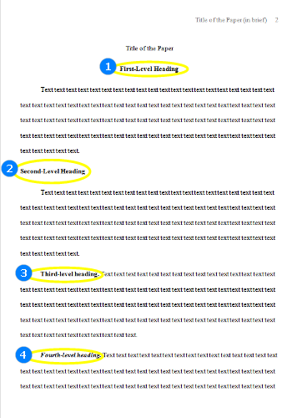

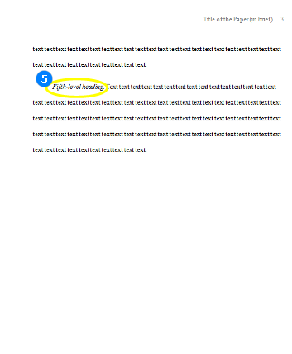

### Reference List

1. The list of sources used in the paper should appear at the end of the paper.
2. It should begin on a new page separate from the text of the essay.
3. It may be labelled ‘References’ or ‘Reference List’.
4. The words ‘References’ or ‘Reference List’ should be centered at the top of the page (NOT bolded, not underlined, not italicized, not in quotation marks).
5. If you name the list of sources ‘Reference List’, please, mind that **both words begin with a capital letter**.
6. All lines after the first line of each entry in the list should be indented one-half inch from the left margin to maintain the hanging indentation.
7. Double-space all entries.
8. Authors' names are inverted (last name first). Do not put periods with the authors’ initials.
9. The titles of books and periodicals are italicized in the Reference List as a rule.
10. The articles or the chapters are not italicized. Use quotation marks for them.
11. Sentence case is used for all the sources except the entire websites and journal titles.

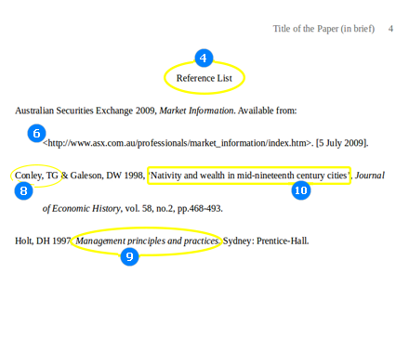

1. For the online sources, the words ‘ Available from’ followed by a colon are used. After the colon, include the URL or the online source. After that, put a period and state the date of access in the square brackets. No punctuation is used inside the brackets.
2. General Format for the book entry is:

Book Author’s Last Name, First Initial(s) Year of Publication. Title of book capitalized like a sentence (italicized), City of Publication: Publisher.

1. General Format for the journal article entry is:

Article Author’s Last Name, First Initial(s) Year of Publication ‘Article title capitalized like a sentence in quotation marks’, Journal Title in the title case (italicized), volume number, issue number after letters ‘no.’, pp. pages.

1. General Format for the website:

The title of the Website, Year of Publication, The name of the source. Available from: < URL >. [Accessed Date of Access]

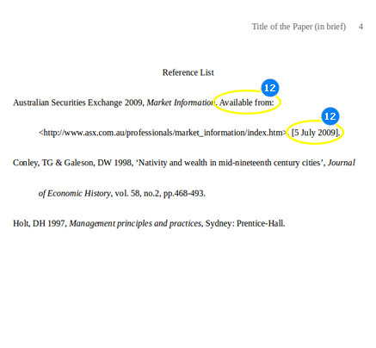

Note:

we do not provide information about how each type of source should be formatted in the References because you may see it HERE.

Let’s sum up how different types of sources should be formatted in Harvard. The following table summarises what font and case should be used for the longer works and for their parts in the text of the paper and in the Reference List.

Type of the SourceIn the textIn Reference List

| Book Title | italicized (but in the in-text quotations not italicized), sentence case | italicized, sentence case |
| --- | --- | --- |
| Title of the Periodical | italicized, title case | italicized, title case |
| Book Chapter | not italicized, not in quotation marks, sentence case | not italicized, not in quotation marks, sentence case |
| Article in Periodical | not italicized, not in quotation marks, sentence case | not italicized, not in quotation marks, sentence case |

### Summing Up…

#### Basic Features of Harvard Style

* Like APA, Harvard presupposes using author name/date system when citing books, articles and other documents.
* The title page contains information about the title of the paper, the student’s name, the name of the course, the professor’s name, the name of the university (school), the city and state where it is located, and the date.
* The title of the paper is in CAPS on the title page and not in CAPS on the first page.
* There is a header on each page which contains a short description of the title and a sequential page number.
* Title case is used for the title of the paper (on the first page), Reference List, titles of periodicals and entire websites. In all other cases sentence case is commonly used.
* Headings are levelled like in APA. The title of the paper on the first page, the Reference List are not levelled. They are just centered, not bolded, in the title case.
* The authors’ names are inverted in the Reference List. The initials are used without periods.
* In the Reference List, the hanging indentation and alphabetical order of entries are maintained.
* For online sources, the words ‘Available from’ are used.
* [Basic features](https://www.uvocorp.com/backend/writing_guide/formatting_styles:_harvard.html#basic-features)
* [Page formatting](https://www.uvocorp.com/backend/writing_guide/formatting_styles:_harvard.html#page-formatting)
* [Citing in Harvard](https://www.uvocorp.com/backend/writing_guide/formatting_styles:_harvard.html#citing)
* [Referencing in Harvard](https://www.uvocorp.com/backend/writing_guide/formatting_styles:_harvard.html#referencing)
* [Headings](https://www.uvocorp.com/backend/writing_guide/formatting_styles:_harvard.html#headings)

## Formatting Styles: IEEE

This section is dedicated to IEEE citation, formatting and referencing style.

IEEE stands for the Institute of Electrical and Electronics Engineers, an association dedicated to advancing innovation and technological excellence. IEEE is the world’s largest technical professional society designed to serve professionals involved in all aspects of the electrical, electronic, and computing fields and related areas of science and technology.

IEEE style is a commonly accepted format for writing research papers in technical fields and computer science. IEEE format is based on the Chicago Style, but has its own peculiar features. For example IEEE citations are numbered, and these numbers are included in the text in square brackets rather than as superscripts. All bibliographical information is exclusively included in the list of references at the end of the document, next to the respective citation number, etc.

Please, review the following links for details about the IEEE format:

* A short and easy to comprehend [IEEE citation and reference guide](https://ieee-dataport.org/sites/default/files/analysis/27/IEEE%20Citation%20Guidelines.pdf);
* An [IEEE conference sample paper](http://www.ieee-pes.org/images/files/pdf/pg4-sample-conference-paper.pdf) with the detailed explanations about the basics of the style;
* An [extended IEEE editorial style manual](http://ieeeauthorcenter.ieee.org/wp-content/uploads/IEEE-Editorial-Style-Manual.pdf).

 While the IEEE citation and referencing style is rarely used in our work we still recommend you to familiarize yourself with its features and hope that this guide and the links to the respective sources will be useful for you.

## Formatting Styles: OSCOLA

This section is dedicated to OSCOLA citation, formatting and referencing style.

While the majority of assignments demand APA or MLA citation styles to be used, the Oxford University Standard for Citation of Legal Authorities (OSCOLA) has specifically been designed to facilitate citation of authorities, legislation, and other legal materials.

Please, review these links for the latest 4th edition of the OSCOLA style and relevant information.

* A very [short OSCOLA manual](https://www.law.ox.ac.uk/sites/files/oxlaw/oscola_4th_edn_hart_2012quickreferenceguide.pdf);
* A full, comprehensive [4th edition](https://www.law.ox.ac.uk/sites/files/oxlaw/oscola_4th_edn_hart_2012.pdf) OSCOLA style manual;
* Useful resource providing comprehensive information about verious aspects of the [OSCOLA](https://www.law.ox.ac.uk/research-subject-groups/publications/oscola)referencing style

 Please, always be specific with the formatting style you are using. Specify which referencing style should be used in your paper when the customer fails to provide such information.

# HOMONYMS

Homonym is a word that is said or spelled the same way as another word but has a different meaning (eg.  "write” and “right”).

Sometimes even the grammar and style checker cannot correctly identify the misused homonym. Therefore, we recommend all writers, and especially our ESL writers, to use this guide regularly.

Please, review the list of homonyms and near-homonyms below. Maybe you will find some that you were not aware of. The list will be updated on a regular basis.

|  |  |  |  |
| --- | --- | --- | --- |
| bear | bare | site | cite |
| complement | compliment | staff | stuff |
| die | dye | suit | suite |
| discrete | discreet | to | two |
| extent | extend | their | there |
| fare | fair | waste | waist |
| forth | fourth | whether | weather |
| great | grate | whole | hole |
| illicit | elicit | past | passed |
| it's | its | personal | personnel |
| lead | lid | principal | principle |
| lie | lye | roll | role |
| new | knew | seem | seam |
| pair | pare |  |  |

# GUIDELINES ON ACADEMIC WRITING

## Proper Paraphrasing

The following short manual will provide several hints useful to properly and effectively paraphrase.

1) **Alternating Active and Passive Forms**. The ability to alternate between active and passive structures is an extremely useful paraphrasing technique. There are, of course, situations in which the passive is preferred to the active:

* When the performer of the action is not known.
* When the performer of the action is not important.
* When the performer of the action is perfectly obvious.
* When the performer of the action refers to the writer

Consider the following examples:

* a) No one knows the exact period when language was first spoken (The actual performer of the action is not known);
* b) This sweater was made in England (The identity of the industrial worker who made the sweater is not important);
* c) French is spoken in France (“By the French people” is obvious);
* d) It can be concluded that further research is necessary (It is the writer who is drawing the conclusion: “I conclude that...”).

The conversion from Active to Passive and vice versa is possible when there is a direct object after the verb:

* - Social motives play a very important role (Active) / A very important role is played by social motives (Passive);
* - You can see that social motives are very important (Active) / It can be seen that social motives are very important (Passive).

No conversion is possible in the following cases:

* a) Verbs WITHOUT Direct Object: This discussion will consist of three parts (Only Active);
* b) Actions without known performers: These techniques were developed in 1958 (Only Passive).

2) **Alternating Word Forms.** An obvious way of expressing an author's thought in your own words is to change the form of one word, from a verb to a noun, adjective or adverb. However, it may be problematic due to the fact that certain words undergo a slight shift in meaning when they change forms. So you should be very attentive when you make any alterations.

ORIGINAL SENTENCE:

* A manager's success is often due to perseverance.

POSSIBLE PARAPHRASES:

* A manager often succeeds because of perseverance.
* Perseverance often leads to managerial success.
* A persevering manager is often successful.
* Successful management is often a result of perseverance.
* A manager who perseveres often succeeds.
* Perseverance often causes a manager to achieve success.
* The success of a manager often stems from perseverance.

3) **Alternating Clause/Phrase Structures**. This method of paraphrasing is to alter the structures which appear in the original text. As a result, the sentence can be either reduced or expanded.

Example of Reduction:

ORIGINAL:

* Although neurons come in many different shapes and sizes, they are all specialized to receive and transmit information (Adverb clause);

PARAPHRASE:

* Despite their different shapes and sizes, neurons are all specialized to receive and transmit information (Adverb Phrase);
* The different shaped and sized neurons are all specialized to receive and transmit information (Noun Phrase).

## Types of Essays

Essay is a shorter piece of writing that requires the student to demonstrate various skills such as close reading, analysis, persuasion, conciseness, clarity etc. Essays should leave no room for the wandering thoughts or derivations from the given topic. In order to mitigate the discomfort associated with essay writing it is important to distinguish between the **four traditional genres** **of essays**: exposition, description, narration and argument.

**Expository essay**is designed to explain a topic. Such essays direct and explain how to accomplish definite tasks. Expository writings investigate, evaluate evidences, expound on an idea and make arguments concerning that idea. This can be accomplished through comparison and contrast, definition, example, analysis of cause and effect, etc.

**Descriptive essay**is intended to describe an object, a person, a place, experience, emotion, situation, etc. Description is painting an image that is vividly moving into the mind of the reader. A successful descriptive essay should make the reader clearly form an impression of the thing, event or experience described in the essay.

A **Narrative essay**is a vivid story depicted in a way that the audience learns a lesson or gains an insight. Narrative essays may sound anecdotal, experiential, and even personal, allowing the writer to express oneself in a creative and moving way. A narrative essay comprises of several important parts:

* A setting, where the story starts or takes place. It is important to describe the physical appearance of such setting with the help of descriptive words or even metaphors and imagery.
* Characters, depicted and taking part in the story. Such characters should be described in detail, including their features, speech, behaviour and how one contradicts with the other.
* A climax, which is a major event in the story. It is important to prepare the reader for the climax gradually and bring it at the end. This will keep the reader glued to the final word.  
  - Sensory words, that appeal to all five senses of the reader.

An **Argumentative essay**requires the writer to collect, generate, and evaluate evidence and establish a position on the topic in a concise manner. Argumentative assignments may require empirical research (conducting interviews, surveys, observations, or experiments). Argumentative essays are intended to convince, persuade and make the readers accept the writer’s way of thinking.

## Reliability/Credibility of Sources

Reliability means that the sources used in your writings are accurate and trustworthy. The Purdue University Writing Lab suggests the following steps in defining the credibility of sources:

* a) **Define the authorship.** A reliable source is written by a reliable author. Such authors cite the sources used in their research to support their arguments and information. On the other hand, sources with no authors (like a number of Internet websites) may not be credible and the information such sources provide may be erroneous.
* b) **Define how recent the source is.** There is a number of fields you may be writing about. While the spheres of religion, history or philosophy may not require recent information, papers on economy, technology, politics, statistics etc. require recent information. In such cases avoid using sources older than 5-10 years.
* c) **Define the author’s purpose.** It is important to carefully check whether the author you are going to cite was unbiased. Each topic may be considered from different viewpoints. Therefore, it is better to use the least biased information, which will not limit your outlook.
* d) **Define the types of sources valued by your audience.**In academic writing it is recommended to use peer-reviewed journals, books, credible periodicals, credible websites.
* e) **Avoid non-reliable Internet sources.** It is recommended to avoid using web-sources where the author is not indicated unless the site is associated with a reputable institution such as a respected university, a credible media outlet, government program or department, or well-known non-governmental organizations.

!!!  
A credible academic source is written by an author who has an academic standing (the opinions of such author are respected). Such sources should contain the date of their publication, which helps the reader identify the relevance of the source to the current state of events, and be available for the reader. Before being published, such sources as books and journals are usually reviewed by other professionals in the same field of knowledge (peers). Such peer-reviewed sources are authoritative enough to be used in academic purposes.

!!!  
In academic, formal writing it is demanded to refrain from using Wikipedia-like websites. While such resources provide easily accessible general information, they are developed by users. This means that anyone can add or change the content of Wikipedia articles, which makes such resources not credible. It is also required to realize whether the Internet source you are going to use will still be available to the reader. Some websites are likely to change, or remove the information you are referring to, which makes them a bad choice to cite for academic purposes. In order to add relevance to such sources, it is recommended to print out the pages used and attach them as appendices.

Finally, the higher the academic level of a writing, the more authoritative sources should be used.  
While high school papers often require the students to use websites as primary sources, the University level writings mostly rely on academic sources, such as peer-reviewed journals, academic books, academic publications created or reproduced in e-form, academically reliable websites.

## Colon (:) vs. Semicolon (;)

These punctuation marks are not typical for definite languages, and their visible similarity may be confusing for a person unfamiliar with their meaning and purpose.

1) **Colon [ :]** should be used (a) before a list or (b) an explanation that is preceded by a clause that can stand by itself. Think of the colon as a gate, inviting one to go on:

* Example: This decision called for only one course of actions: revolt! (b)
* Example: This sentence contains the following parts of speech: a noun, an adjective and a verb. (a)

2) **Semicolon [;]** is used: to (a) connect two independent clauses together into one sentence, (b) as a super-comma, (c) between items in a series or listing containing internal punctuation:

* Example: This could be a complete sentence; this could be another one.  
    
  If you put a comma where that semicolon is, you will have committed a "comma splice," which is a nasty grammar error.

There is, however, one exception that can cause you a problem. You don't use a semicolon to connect two complete sentences if there's a conjunction between the clauses (and, but, etc.). In that case, use a comma:

* Example: This could be a complete sentence, and this could be another one.  
  Adding that single word, the conjunction "and," means that you must change that semicolon into a comma.

## Avoiding Contractions

**Avoiding contractions in formal writing** is a typical requirement.

Contraction is a shortened form of a word from which one or more letters have been omitted. The apostrophe is used in writing contractions. In standard English, this generally happens only with a small number of conventional items. While largely acceptable in speech, **contractions** are too informal and **should not be used in academic writing**.

Examples of common contractions: “I’d”, “she'd've”, “can’t”, “shouldn’t”.

There are few exceptions, like “o’clock”. Such contractions are allowed as they have traditionally assumed the form of a full word.

Contractions should not be confused with abbreviations. Such shortened forms as Mr., Mrs., bc., e.g. are allowed in formal writing.

Finally, contractions in foreign words and names are also allowed: D'Angelo, McTavish.  Such word forms are not considered as contractions because there is no alternative way of writing them.  
There are other contractions which are often heard in speech, like: - 'Fraid so. - 'Nother drink? - I s'pose so. - 'S not funny. It is, of course, never appropriate to use such colloquial forms in formal writing, except when you are explicitly writing about colloquial English, or cite the original colloquial text.

## Inclusive Language

**Writing inclusively** means to avoid expressions and words that exclude particular groups of people.

For example, gender-specific words, like “man”, “mankind”, masculine or feminine pronouns etc. are considered to exclude other genders. Formal writing avoids value judgements about anyone based on their gender, because such statements diminish objectivity, therefore it is important to avoid:

* emphasizing gender inappropriately or irrelevantly;
* treating women and men unequally;
* minimise or trivialise women or men.

- The following specific **techniques**are helpful in writing inclusively:  
Historically, pronoun “he” has been used as a generic term. But in contemporary formal writing it should be avoided when possible. “He/she” is an alternative that may be used, but it adds awkwardness especially due to repetitions in various contexts: “If a writer sees that he/she has mistakes with his/her paper, he/she should seek help from his/her supervisor.”  
In such case using pronoun “they” will be helpful: “If writers see that they have mistakes with their papers, they should seek help from their supervisors.”  
  
- Another technique presumes avoiding words or phrases indicative of gender when gender is irrelevant: “I went to a function for the celebrated lady novelist.” No-one would say “I went to a function for the celebrated man novelist”, so this gender identification implies that the novelist is a dilettante, a woman who writes as a kind of elegant hobby rather than as a serious career. If you need to identify her further, use her name:  
“I went to a function for the celebrated novelist, Keri Hulme.”  
  
- Taking heed of compound words also improves style: astronaut vs. spaceman, humanity vs. mankind, artificial vs. manmade, sales representative vs. salesman.

- Avoid diminutives to imply female: usher vs. usherette, poet vs. poetess. Neither ushers nor poets are inherently male or female.  
  
Other specific cases: “woman” and “women” are more commonly used than “lady” and “ladies”. Paired words should be equal: “man and woman” or “husband and wife” should be used instead of “man and wife”

## Colloquialisms

Academic writing requires accurate, formal English. Please, take a look at the rules below and try to follow them in future.  
  
- **Anybody, anyone:** Anyone and its variants are more formal than anybody and its variants.

**As:** As is often used in formal writing to mean because. Placing a comma before “as” can help prevent ambiguity when it could also be understood to mean “when” or “where.”

**Big, large, great:** All these words are acceptable in formal English, but large is more formal than big, and "great" is more formal than "large."

**Fellow:** Avoid using fellow when you mean a person. Calling someone a fellow is more formal than calling him or her a dude, but fellow is still a colloquialism.

**For sure:** Replace "for sure" with "with certainty"in formal writing.

**Get:** Avoid all forms of this verb in formal writing: “I received an A in the course.” vs. “I got an A in the course”; “She did not understand the joke.” vs. “She didn’t get the joke.”; “The machine is never used.” vs. “The machine never gets used.”;

**Got**: Got is a colloquialism. Replace it with have, as in “Do you have [not "got"] an extra pen?"

**Kind of, sort of:** "Kind of" and "sort of" are unacceptable in formal writing when used for "somewhat" and "rather." When used to categorize something, "kind of" and "sort of" are acceptable, but "type of" is more formal: “Kestrel is a type of bird." Note that it is informal to include an article after "of": "Kestrel is a type of a bird."

**Let:** When used in place of "allow" or "permit," "let" is a colloquialism.

**Most**: In formal English, do not use "most" for "almost." You should write, "Almost everyone likes pizza," not "Most everyone likes pizza."

**On the other hand:** "On the other hand" is a very common phrase, but can be considered a cliché and should, therefore, be avoided in extremely formal English. Instead, use "conversely" or "by contrast." "On the other hand" is particularly useful in everyday writing and can eliminate the temptation to start with "but."

**So:** Avoid using "so" as a synonym for "very" in extremely formal writing. In perfectly formal writing, you also should avoid using "so" as a coordinating conjunction. You can eliminate this colloquialism by deleting "so" and beginning the sentence with "because." Compare "The song may bother me, so I’ll cover my ears" and "Because the song may bother me, I shall cover my ears." Sometimes, you need the conjunction "that" after "so," as in "I wrote this how-to so that you could improve your grammar and style."

**-ly:** Usually, the words ending "-ly" are more formal. For example, "firstly" is more formal than "first."

## Generalization

**Generalization** is an extension of a concept to a less-specific criterion. Writers often use generalization if they cannot come up with specifics or be clear. In fact, generalization diminishes the value of academic writing and undermines the authority of the writer, causing the readers to feel the ground on which they are treading is a bit shaky. Formal writing requires specificity and well-supported information. Generalization leads to inaccuracy in statements, which is a serious flaw in a formal text.  
  
Use of the words always, all, every, everyone, many, never, nobody, none can create inaccurate statements, and even factual errors. It leaves the reader disbelieving the writer. These inaccuracies could produce false statements about people, places or things. (e.g. “Marketing will solve the problem for an organization.” - that does not tell the reader anything about the solution - be more specific about your statements.)

**Avoiding generalization** is easy:

* 1. *Be specific*. After reading a piece, the reader should know exactly what the author was conveying. Avoid being ambiguous. If you are a non-native English speaker, try reading out loud what you have written and translate it for yourself. Have you written something reasonable? Something you yourself would have easily understood?
* 2. *Use facts*, data, statistics, and other research. Instead of writing all, always or never about a subject, do the real research. Find out **how many!**.
* 3. Use quotes. Use and attribute quotes by other authoritative sources to make your points. Being specific means that you should not simply state a fact; you need to prove this fact. Formal writing requires you to quote and reference.
* 4. *Quantify, don't qualify*. Use real quantities and numbers, rather than qualifiers. But if you do qualify, select the qualifier carefully. Some is better than all or none.
* 6. Do not overstate a situation. Exaggeration causes unintended bias.
* 7. *Break down the topic*. The best way to avoid generalizations is to break down a broad topic into smaller topics. This will force the writer to get specific.

## Avoid Personal Language

The convention in academic writing is to **write with** **minimal reference to yourself** as an author.

The reason for this lies in a tradition of needing to present your work "objectively", as the work of a dispassionate and disinterested (unbiased) researcher. Personal language is subjective and therefore may decrease the authority of the argument. Personal pronouns "I, we, our" make the reader aware of the writer's presence in the text. Judgmental words, "I believe", "I disagree", exacerbate the issue of the writer's presence in the text because the reader becomes aware of the writer's personal feelings about the argument. The use of emotive words, "repulsive", "undignified", creates text that is persuasive, increasing the subjective and personal nature of the text.

Academic writing is all about expressing opinion, yet this opinion needs to be presented as an objective, educated position based on sound evidence. Your text should provide and reference this supporting evidence. So, one of the features of academic writing is a general absence of the first person pronouns. A professional writer needs to let the assignment "speak for itself":

"I show..." becomes "The report shows..."

"I interpret the results as..." becomes "The results indicate..."

Another way to avoid the first person is to use the passive voice construction:

"We administered the questionnaire..." becomes "The questionnaire was administered...";

"I surveyed the literature" becomes "The literature was surveyed".

At the same time, overusing of passive voice is also a style mistake, which should be avoided.

## Be Concise

**Being concise** is to write exactly what you have to, avoiding redundancy. Do not waffle, do not be evasive. In formal writing it is a sign of a good writing style to write as few words as possible to get to the point. It is one of the reasons why instructors impose word limits on written assignments.  
  
It is recommended to apply the following techniques to reduce overflow of unnecessary words in a paper:

* Make your points straight away: “Firstly, ...”, “Secondly…”, “Finally…”
* Replace phrases with single words: “Smith(2006) agreed, but considered the fact that some managers preferred to have longer, all-day meetings.” instead of “Smith (2006) also believed this to be true, but took into consideration the fact that some managers also preferred to have long meetings that took all day”

Avoiding words with the same meaning: “Records” instead of “past records”, "Separate” instead of "separate out”, “In retrospect” instead of “looking back in retrospect”.

Omit unnecessary words: “lowering the rope” instead of “lowering the rope down”, “measuring the job” instead of “measuring up the job”, “because” instead of “due to the fact that”.

Avoid saying the same thing twice: “The farmer sheared the sheep and removed all their wool” could simply be replaced with “The farmer sheared the sheep”  
Avoid clumsy sentences with extra words that detract from the point: “There are several of the soldiers, each with their guns and ammunition, who gathered at the gates of the camp before dawn.” A better way would be to say: “Several of the soldiers, each with their own guns and ammunition, gathered at the camp gates before dawn.”

## Objective Writing

Academic writing is a special sphere different from other writing contexts. Academic (formal) writing has a number of requirements, like: formal order or structure in which to present ideas, support ideas by properly made citations, particular ‘tone’, traditional conventions of punctuation, grammar, and spelling. Finally, formal writing should be objective.

In order to write objectively it is important to be concerned with facts and avoid personal feelings or biases. Being objective also means fairness. As an independent researcher a writer has to show both sides of an argument and avoid making value judgements through the use of words such as “wonderful”, “pretty”, etc. An objective work sounds professionally and believable.

Another key practice intended to make your writing professional and objective is avoiding personal pronouns when necessary. Writing impersonally is a key to make your writing believable and unbiased. For example, readability improves when a writer uses “It could be argued that…” instead of “I think…”. “The studies show that...” instead of “I believe...” or “They say...”. Writing impersonally also means to use citations to express your views, e.g. “Thompson (2012) believes that…”.

Formal writing discourages the use of first or second person (‘I’, ‘we’, ‘you’, etc.). These pronouns diminish the objective tone of formal writing. Instead, it sounds as though a writer has a limited, personal view of the issue under discussion, rather than a view of the broader picture. In some circumstances, however, it is appropriate to write in the first or second person, according to the writing style, requirements and the discipline. For example, reflective writing relies on personal experience.

## Some Facts about Structure

Grammar and structure of your paper are the two key aspects that make up a grade-A writing. In an attempt not to overlook grammar writers (especially non-native speakers) often underrate the value of a perfect paper structure. Such attitude to your writing is a serious mistake, as only a well-structured paper may be effective and will show that you have properly elaborated your topic.

Please, read about the following parts of your paper:

**Paragraph** - a professional writer should remember that a paragraph is a single "unit" of a paper. Reading a paragraph the reader expects to see well-elaborated representation of a <b>single </b>point or thought, and find a proper support for that point. Violating this expectation (wandering paragraphs, aimlessly splitting into a number of ideas, often unrelated; declaration of ideas without evidence or support) makes your paper unreadable, signifies of a poor writing style, and simply leads to a revision request in the best case, or a total customer dissatisfaction and a refund in the worst.

**Introduction**: usually about 3-4 sentences. Should not exceed the following body paragraph. Introduction contains: a Hook - a sentence, which from the first line intends to grasp the reader’s attention subconsciously motivating him to read up to the end; and a Thesis Statement:  The last sentence of your Introduction, where you take certain position you are going to stick to in your paper. This sentence is mandatory!

Topic sentence: Each body paragraph of your paper should start with a topic sentence, which is a statement that you are going to discuss, claim or oppose in the following paragraph.

**Conclusion**: Last sentence of your paper, which finalizes your paper by providing the results of your research, your key points given and defended in the body of your paper. Conclusion should not contain any new points or data, as it should not raise any more questions.

Basic Structure: Introduction and Conclusion is a MUST to be in every paper. Each paragraph should contain at least 3 sentences. Body paragraphs should contain references when the need to support your points arises.

## Readability

**Readability** is the ease with which the reader perceives your text.

Proper readability is a significant factor that contributes to the overall perception and acceptance of your thoughts and arguments. Please, remember these golden rules of readability that apply irrespective of the type of your paper:

* Use simple, familiar terms,
* Avoid jargon,
* Use culture-and-gender-neutral language,
* Use correct grammar, punctuation, and spelling,
* Use simple sentences, active voice, and present tense,
* Begin instructions in the imperative mode by starting sentences with an action verb,
* Use simple graphic elements such as bulleted lists and numbered steps to make information visually accessible.
* Carefully and properly proofread your completed writing before uploading (we recommend proofreading your paper 30 minutes after having finished it),
* Do not make the paper too complicated and hard to read. Please read twice what you wrote and make sure it flows smoothly,
* Avoid wordiness.

# ORGANIZATION AND STRUCTURE OF ESSAYS

## Basic Elements of the Paper

A well-organized, grade-A paper should have perfect structure. Every part of the essay should have its purpose, be coherent and correctly formatted.

The following are the inevitable constituents of any essay:

* [Introduction](https://www.uvocorp.com/backend/writing_guide/organisation_and_structure_of_essays.html#introduction)
* [Main Body](https://www.uvocorp.com/backend/writing_guide/organisation_and_structure_of_essays.html#main-body)
* [Conclusion](https://www.uvocorp.com/backend/writing_guide/organisation_and_structure_of_essays.html#conclusion)

## Other Structural Elements of the Paper

* [Outline](https://www.uvocorp.com/backend/writing_guide/organisation_and_structure_of_essays.html#outline)
* [Abstract](https://www.uvocorp.com/backend/writing_guide/organisation_and_structure_of_essays.html#abstract)
* [Summary](https://www.uvocorp.com/backend/writing_guide/organisation_and_structure_of_essays.html#summary)

### Introduction

* It must create first impression of the paper;
* It must contain the hook (some point which will be developed further);
* It must contain background information;
* It must have a thesis statement;
* It must be concise but specific

### Ways to Start an Introduction

* With a question
* With an interesting, little-known fact
* With a meaningful quote
* With a shocking story

### Thesis Statement

*In a typical essay, the first sentence (curtain sentence) leads into two or three sentences that provide details about your subject. All of these sentences build up to your thesis statement.*

*The thesis statement is a sentence or two in the text that contain the focus of the essay and tell the reader what the essay is going to be about. The entirety of the paper hangs on that sentence. But its function is to be informative and direct.*

### Ways to Give Background Information

* Provide statistics
* Give historical information
* Explain why the topic is important
* Explain causes and effects
* Use a quote from a prominent figure that relates to your topic

### Main Body

* Each paragraph should have one idea
* Each paragraph should be important
* Each paragraph should connect with the preceding and following paragraph
* Topic sentence, assertion, example, explanation, significance

### Conclusion

* Reminds but does not repeat main points
* Shows what was written was important
* Has an afterthought

### Reminding

* Covers all key points, with one sentence each if possible
* Don't use the same words and phrases as before: readers need to see them from a different angle
* Look at the thesis statement and check the conclusion after it is written to see if it matches

### Showing Importance

* You must have a "because" element
* Uses effective language that will make your readers have an emotional response
* Don't be passive — keep strong with assertions

### Afterthought

* Could be a question, a vivid image of what is to come, or a statement someone could ponder over for a long time
* In purely technical essays, like ones that are laboratory studies, you don't need them
* Don't add new information in the conclusion

## Outline

* Key phrases so your mind remembers
* Put thesis statement at the top
* Play with the order of paragraphs to see which is most effective

### Tips for Creating Outlines

* Keep your thesis statement at the top
* Separate main points and subpoints clearly
* Make sure you brainstorm before
* Edit your outline at least once
* Check your outline for flow (logical)
* Separate the parts of the paper clearly
* When you are done, refer to your assignment guidelines

### Outline Style Options

Degrees of information

* Hint (Keywords that make you remember what you want to discuss when you are writing; Incomplete sentences are okay; Specific details not used).
* Detailed (Besides keywords, specifics are given; Information you are considering).
* Descriptive (Like a fill in the blank sheet; a first draft that's even messier than a first draft).

### Outline Formatting Options

* Alphanumeric  
  Use roman numerals for headings, letters for subheadings, and regular numbers for information about subheadings.
* Full Sentence  
  Everything, even headings, are written in full sentence form. Headings are shown by numbers and subpoints are shown by letters.
* Decimal Outline  
  Headings are written in decimal form, such as 1.0, whereas subtopics are written as 1.4 and such.

### Abstract

What you should keep in mind while writing an abstract:

* get readers interested in your work;
* do not use business language or buzzwords;
* it should go from general to specific

### Summary

* Give readers a look into what the paper is about
* Cover each major point
* Do not include any of your own ideas

### Difference

Summary — Quick knowledge

Abstract — Entice

Outline — Plan

Conclusion — Remind and answer: so what?

## Tips for Arranging Paragraphs and Developing Main Points Clearly

* Each paragraph should contain a topic sentence which would point to your thesis statement and a specific paragraph simultaneously.
* All the sentences following the topic sentence in the paragraph must follow the idea of the TS.
* Your topic sentence should be a hook to interest readers.
* Thesis statement and topic sentences should state a controlling idea which expresses your attitude towards something based on facts. (e.g. Facts: My dog is a small pug, has straight hair, and has big goooooogly eyes. Controlling idea: My dog looks like an adorable anime character).
* A controlling idea should be backed by supporting ideas (separate paragraphs for each idea).
* The number of paragraphs should depend on the expansiveness of your subject and support you have.  
  Paragraphs should be ordered by the logical flow of ideas

# PARALLELISM

This topic has not yet been discussed in the 'Writing Guide', nor at the forum. Still, in line with the ban for colloquial speech, parallelism is one of the most important concepts in formal writing we would like to draw your attention to.

*Parallelism* means expressing similar parts of a sentence in a consistent way. In other words, the elements that are similar in their function should be alike in construction too.

Though the definition might seem a bit too sophisticated, the application of parallel forms in practice is very simple and rather ordinary. These examples from Wikipedia perfectly show what we mean:

**Example 1:**

* Lacking parallelism: "She likes cooking, jogging, and to read."
* Parallel form: "She likes cooking, jogging, and reading." or “She likes to cook, jog, and read."

**Example 2:**

* Lacking parallelism: "He likes to swim and *running*."
* Parallel form: "He likes to swim and to run." or "He likes swimming and running."

Parallelism in your writing serves as a key element in developing your style. It builds clarity and consistency. Take a look at another example:

**Example 3:**

* Parallel form: “In the summer before college, I waited tables, sold magazines and even delivered pizzas.”
* Non-parallel form: “In the summer before college, I was a waiter at a restaurant, pursued magazine sales and pizza delivery was my third job.” The parallel version here reads much more smoothly.

Please, remember to use parallel forms in your writing and feel free to read up on parallelism on-line.

# PLAGIARISM: WHAT IT IS AND HOW TO RECOGNIZE AND AVOID IT

## What is Plagiarism and Why is it Important?

In college courses, we are continually engaged with other people's ideas: we read them in texts, hear them in lecture, discuss them in class, and incorporate them into our own writing. As a result, it is very important that we give credit where it is due. Plagiarism is using others' ideas and words without clearly acknowledging the source of that information.

## How Can Writers Avoid Plagiarism?

To avoid plagiarism, you must give credit whenever you use:

* Another person's idea, opinion, or theory;
* Any facts, statistics, graphs, drawings—any pieces of information—that are not common knowledge;
* Quotations of another person's actual spoken or written words; or
* Paraphrase of another person's spoken or written words.

To help you recognize what plagiarism looks like and what strategies you can use to avoid it scroll down to the appropriate topic.

## How to Recognize Unacceptable and Acceptable Paraphrases

Here's the **ORIGINAL** text, from page 1 of Lizzie Borden: A Case Book of Family and Crime in the 1890s by Joyce Williams et al.:

***The rise of industry, the growth of cities, and the expansion of the population were the three great developments of late nineteenth century American history. As new, larger, steam- powered factories became a feature of the American landscape in the East, they transformed farm hands into industrial laborers, and provided jobs for a rising tide of immigrants. With industry came urbanization the growth of large cities (like Fall River, Massachusetts, where the Bordens lived) which became the centers of production as well as of commerce and trade.***

Here's an **UNACCEPTABLE** paraphrase that is plagiarism:

***The increase of industry, the growth of cities, and the explosion of the population were three large factors of nineteenth century America. As steam-driven companies became more visible in the eastern part of the country, they changed farm hands into factory workers and provided jobs for the large wave of immigrants. With industry came the growth of large cities like Fall River where the Bordens lived which turned into centers of commerce and trade as well as production.***

**What makes this passage plagiarism?**

The preceding passage is considered plagiarism for two reasons:

* The writer has only changed around a few words and phrases, or changed the order of the original's sentences.
* The writer has failed to cite a source for any of the ideas or facts.

**If you do either or both of these things, you are plagiarizing.**

This paragraph is also problematic because it changes the sense of several sentences (for example, "steam-driven companies" in sentence two misses the original's emphasis on factories).

Here's an **ACCEPTABLE** paraphrase:

***Fall River, where the Borden family lived, was typical of northeastern industrial cities of the nineteenth century. Steam-powered production had shifted labor from agriculture to manufacturing, and as immigrants arrived in the US, they found work in these new factories. As a result, populations grew, and large urban areas arose. Fall River was one of these manufacturing and commercial centers (Williams 1).***

**Why is this passage acceptable?**

This is acceptable paraphrasing because the writer:

* Records the information in the original passage accurately.
* Gives credit for the ideas in this passage.
* Indicated which part is taken directly from her source by putting the passage in quotation marks and citing the page number.

Note that if the writer had used these phrases or sentences in her own paper without putting quotation marks around them, she would be PLAGIARIZING. Using another person's phrases or sentences without putting quotation marks around them is considered plagiarism **EVEN IF THE WRITER CITES IN HER OWN TEXT THE SOURCE OF THE PHRASES OR SENTENCES SHE HAS QUOTED**.

## Plagiarism and the World Wide Web

The World Wide Web has become a more popular source of information for student papers, and many questions have arisen about how to avoid plagiarizing these sources. In most cases, the same rules apply as to a printed source: when a writer must refer to ideas or quote from a WWW site, she must cite that source.

If a writer wants to use visual information from a WWW site, many of the same rules apply. Copying visual information or graphics from a WWW site (or from a printed source) is very similar to quoting information, and the source of the visual information or graphic must be cited. These rules also apply to other uses of textual or visual information from WWW sites; for example, if a student is constructing a web page as a class project, and copies graphics or visual information from other sites, she must also provide information about the source of this information. In this case, it might be a good idea to obtain permission from the WWW site's owner before using the graphics.

## Strategies for Avoiding Plagiarism

* 1. Put in quotations everything that comes directly from the text especially when taking notes.
* 2. Paraphrase, but be sure you are not just rearranging or replacing a few words.
* Instead, read over what you want to paraphrase carefully; cover up the text with your hand, or close the text so you can't see any of it (and so aren't tempted to use the text as a “guide"). Write out the idea in your own words without peeking.
* 3. Check your paraphrase against the original text to be sure you have not accidentally used the same phrases or words, and that the information is accurate.

## Terms You Need to Know ( or What is Common Knowledge ? )

**Common knowledge:** facts that can be found in numerous places and are likely to be known by a lot of people.

Example: John F. Kennedy was elected President of the United States in 1960.

This is generally known information. **You do not need to document this fact**.

However, you must document facts that are not generally known and ideas that interpret facts.

Example: According the American Family Leave Coalition's new book, Family Issues and Congress, President Bush's relationship with Congress has hindered family leave legislation (6).

The idea that "Bush's relationship with Congress has hindered family leave legislation" is not a fact but an interpretation; **consequently, you need to cite your source**.

**Quotation**: using someone's words. When you quote, place the passage you are using in quotation marks, and document the source according to a standard documentation style.

The following example uses the Modern Language Association's style:

Example: According to Peter S. Pritchard in USA Today, “Public schools need reform but they’re irreplaceable in teaching the entire nation’s young” (14).

Paraphrase: using someone’s ideas, but putting them in your own words. This is probably the skill you will use most when incorporating sources into your writing. Although you use your own words to paraphrase, you must still acknowledge the source of the information.

**SUBJECT-VERB DISAGREEMENT**

The rule of thumb to remember: a sentence subject must agree with the verb of the sentence in number (singular or plural) and person (1st, 2nd or 3rd person).

Example of subject-verb disagreement:

He are my favorite writer.

* The subject: He (singular)
* The verb: are (plural)

In this example, the verb and the subject disagree in number. It is a common mistake especially for ESL writers, which is very easy to avoid.

Below you will see several examples of subject-verb disagreement, and will find ways to avoid it. Each example below has particular features. Please, carefully look through this guide.

### Types of Subject-Verb Disagreement (correct examples are in the right-hand column):

1. Usually, especially in a complex sentence, the **subject and the verb are separated**. It, therefore, may be hard to see the mistake whenever you make one. We therefore recommend to 1st identify the subject and the verb and ignore the words in-between, since they have no influence on the subject-verb agreement.

|  |  |
| --- | --- |
| The characters in Shakespeare’s Twelfth Night lives in a world that has been turned upside-down. | The characters in Shakespeare’s Twelfth Night live in a world that has been turned upside-down. |

1. Proofreading a sentence with **compound subjects** may be quite a task even for an experienced writer, especially after hours of work. Therefore, we recommend following the lifesaver rule:
   * When the two subjects are connected by “and,” the verb will be plural in most situations (except cases when the joined subjects are preceded by “every,” “no,” or “nothing”);
   * When the subjects are joined by “nor” or “or,” the verb agrees with the closer subject (the last one).

|  |  |
| --- | --- |
| Christie and Prin is characters from Laurence’s The Diviners. | Christie and Prin are characters from Laurence’s The Diviners. |
| Neither Edna’s neighbors nor her husband agree with her decision. | Neither Edna’s neighbours nor her husband agrees with her decision. |

1. Be cautious with **indefinite pronouns**:
   * Use singular verbs with single indefinite pronouns (none, anybody, each, either, anyone);
   * Use plural verbs with plural indefinite pronouns (both, few, many, several);
   * Depending on the situation the words ‘some, all, any, most’ can be either singular or plural.

|  |  |
| --- | --- |
| Each of Sylvia Plath’s “bee poems” use the theme of beekeeping to express the human condition. | Each of Sylvia Plath’s “bee poems” uses the theme of beekeeping to express the human condition. |
| Both of the main characters in Waiting for Godot believes Godot is the purpose of life. | Both of the main characters in Waiting for Godot believe Godot is the purpose of life. |

1. **Plural nouns** that are singular in meaning:
   * Some plural nouns take singular verbs, for example: athletics, economics, politics, news, mumps, and measles.

|  |  |
| --- | --- |
| Politics arethe topic of the research paper. | Politics isthe topic of the research paper. |

1. **Titles**:
   * When used in sentences, the titles of books, plays, poems, movies, and so on are singular.

|  |  |
| --- | --- |
| Salman Rushdie’s Midnight’s Children are my favorite novel. | Salman Rushdie’s Midnight’s Children is my favorite novel. |

# THESIS STATEMENT: HOW TO MAKE IT STRONGER

## What is Thesis Statement

The **Thesis Statement** is that sentence or two in your text that contains the focus of your essay and tells your reader what the essay is going to be about.

You may think of a thesis statement as an umbrella: everything that you carry along in your essay has to fit under this umbrella, and if you try to take on packages that don't fit, you will either have to get a bigger umbrella or something's going to get wet.

## A Thesis Statement:

* Tells the reader how you will interpret the significance of the subject matter under discussion.
* Is a road map for the paper; in other words, it tells the reader what to expect from the rest of the paper.
* Directly answers the question asked of you. A thesis is an of a question or subject, not the subject itself.  
  e.g.The subject, or topic, of an essay might be World War II or Moby Dick; a thesis must then offer a way to understand the war or the novel.
* Makes a claim that others might dispute.
* Is usually a single sentence (or two) somewhere in your first paragraph that presents your argument to the reader. The rest of the paper, the body of the essay, gathers and organizes evidence that will persuade the reader of the logic of your interpretation.

## Is Essay Without a Thesis Statement Possible?

Although it is sometimes possible to write a good essay without a thesis statement (many narrative essays, for example, contain only an implied thesis statement), the lack of a thesis statement may well be a symptom of an essay beset by a lack of focus (this must not be a case for University and Master's writers).

## How Do I Get a Thesis?

A thesis is the result of a lengthy thinking process. Formulating a thesis is not the first thing you do after reading an essay assignment. Before you develop an argument on any topic, you have to collect and organize evidence, look for possible relationships between known facts and think about the significance of these relationships. Once you do this thinking, you will probably have a "working thesis," a basic or main idea, an argument that you think you can support with evidence.

The thesis statement should remain flexible until the paper is actually finished. If you discover new information in the process of writing your paper that ought to be included in the thesis statement, then you'll have to rewrite your thesis statement. On the other hand, if you discover that your paper has done adequate work but the thesis statement appears to include things that you haven't actually addressed, then you need to limit that thesis statement.

## What Is a Strong Thesis?

Very often, writers include a thesis statement to the introduction. However, it is not strong enough.

To make your thesis strong, ask yourself seven questions:

*Where is my thesis statement?*

*You should provide a thesis early in your essay — in the introduction, or in longer essays in the second paragraph — in order to establish your position and give your reader a sense of direction.*

*Do I answer the question?*

*Re-reading the question prompt after constructing a working thesis can help you fix an argument that misses the focus of the question.*

*Have I taken a position that others might challenge or oppose?*

*If your thesis simply states facts that no one would, or even could, disagree with, it's possible that you are simply providing a summary, rather than making an argument.*

*Is my thesis statement specific enough?*

*Thesis statements that are too vague often do not have a strong argument. Your thesis should be limited to what can be accomplished in the specified number of pages. Shape your topic so that you can get straight to the "meat" of it e.g. If your thesis contains words like "good" or "successful", see if you could be more specific: why is something "good"; what specifically makes something "successful"?*

*Compare this original thesis (too general) with three possible revisions (more focused, each presenting a different approach to the same topic):*

###### ORIGINAL THESIS (WEAK):

*There are serious objections to today's horror movies.*

###### REVISED THESES (STRONG):

* *Because modern cinematic techniques have allowed filmmakers to get more graphic, horror flicks have desensitized young American viewers to violence.*
* *The pornographic violence in "bloodbath" slasher movies degrades both men and women.*
* *Today's slasher movies fail to deliver the emotional catharsis that 1930s horror films did.*

## *Is my thesis statement clear?*

*Your thesis statement is no exception to your writing: it needs to be as clear as possible. By being as clear as possible in your thesis statement, you will make sure that your reader understands exactly what you mean.*

###### TIP: IN ORDER TO BE AS CLEAR AS POSSIBLE IN YOUR WRITING:

* *Unless you're writing a technical report, avoid technical language. Always avoid jargon, unless you are confident your audience will be familiar with it.*
* *Avoid vague words such as "interesting", "negative", "exciting", "unusual", and "difficult".*
* *Avoid abstract words such as "society", "values", or "culture".*

*These words tell the reader next to nothing if you do not carefully explain what you mean by them. Never assume that the meaning of a sentence is obvious. Check to see if you need to define your terms ("socialism", "conventional", "commercialism", "society"), and then decide on the most appropriate place to do so. Do not assume, for example, that you have the same understanding of what "society" means as your reader. To avoid misunderstandings, be as specific as possible.*

*Compare the original thesis (not specific and clear enough) with the revised version (much more specific and clear):*

###### ORIGINAL THESIS (WEAK):

*Although the timber wolf is a timid and gentle animal, it is being systematically exterminated. [if it's so timid and gentle, why is it being exterminated?]*

###### REVISED THESIS (STRONG):

*Although the timber wolf is actually a timid and gentle animal, it is being systematically exterminated because people wrongfully believe it to be a fierce and cold-blooded killer.*

## *Does my thesis include a comment about my position on the issue at hand?*

*The thesis statement should do more than merely announce the topic; it must reveal what position you will take in relation to that topic, how you plan to analyze/evaluate the subject or the issue. In short, instead of merely stating a general fact or resorting to a simplistic pro/con statement, you must decide what it is you have to say.*

###### TIPS:

* *Avoid merely announcing the topic; your original and specific "angle" should be clear. In this way you will tell your reader why your take on the issue matters.*
* *Avoid making universal or pro/con judgments that oversimplify complex issues.*
* *When you make a (subjective) judgment call, specify and justify your reasoning. "Just because" is not a good reason for an argument.*
* *Avoid merely reporting a fact. Say more than what is already proven fact. Go further with your ideas. Otherwise... why would your point matter?*
* *Though it is not a strict rule, it is better not to announce the thesis statement as if it were a thesis statement using phrases such as "The purpose of this paper is..." or "In this paper, I will attempt to...".*

*Compare the original thesis (not specific and clear enough) with the revised version (much more specific and clear):*

###### ORIGINAL THESIS (WEAK):

*In this paper, I will discuss the relationship between fairy tales and early childhood (not specific; "why does the topic matter?").*

###### REVISED THESIS (STRONG):

*Not just empty stories for kids, fairy tales shed light on the psychology of young children.*

###### ORIGINAL THESIS (WEAK):

*We must save the whales (just a universal claim; no reason stated).*

###### REVISED THESIS (STRONG):

*Because our planet's health may depend upon biological diversity, we should save the whales.*

###### ORIGINAL THESIS (WEAK):

*Socialism is the best form of government for Kenya (subjective; not justified).*

###### REVISED THESIS (STRONG):

*If the government takes over industry in Kenya, it will become more efficient.*

###### ORIGINAL THESIS (WEAK):

*Hoover's administration was rocked by scandal (thesis just reports a fact).*

###### REVISED THESIS (STRONG):

*The many scandals of Hoover's administration revealed basic problems with the Republican Party's nominating process.*

## *Is my thesis statement original?*

*Avoid generic arguments and formula statements. They work well to get a rough draft started, but will easily bore a reader. Keep revising until the thesis reflects your real ideas.*

###### TIP: THE POINT YOU MAKE IN THE PAPER SHOULD MATTER:

* *Be prepared to answer "So what?" about your thesis statement.*
* *Be prepared to explain why the point you are making is worthy of a paper. Why should the reader read it?*

*Compare the following:*

###### ORIGINAL THESIS (WEAK):

*There are advantages and disadvantages to using statistics (****a fill-in-the-blank formula****).*

###### REVISED THESES (STRONG):

* *Careful manipulation of data allows a researcher to use statistics to support any claim she desires.*
* *In order to ensure accurate reporting, journalists must understand the real significance of the statistics they report.*
* *Because advertisers consciously and unconsciously manipulate data, every consumer should learn how to evaluate statistical claims.*

*Avoid formula and generic words. Search for concrete subjects and active verbs, revising as many "to be" verbs as possible. A few suggestions below show how specific word choice sharpens and clarifies your meaning.*

###### ORIGINAL (PRETENDS TO BE A WEAK THESIS):

*"Society is..." [who is this "society" and what exactly is it doing?]*

###### REVISED (PRETENDS TO BE A STRONG THESIS):

*"Men and women will learn how to...", "writers can generate...", "television addicts may chip away at...", "American educators must decide...", "taxpayers and legislators alike can help fix..."*

###### ORIGINAL (PRETENDS TO BE A WEAK THESIS):

*"the media"*

###### REVISED (PRETENDS TO BE A STRONG THESIS):

*"the new breed of television reporters", "advertisers", "hard-hitting print journalists", "horror flicks", "TV movies of the week", "sitcoms", "national public radio..."*

###### ORIGINAL (PRETENDS TO BE A WEAK THESIS):

*"is, are, was, to be" or "to do, to make"*

###### REVISED (PRETENDS TO BE A STRONG THESIS):

*any great action verb you can concoct: "to generate", "to demolish", "to batter", "to revolt", "to discover", "to flip", "to signify", "to endure..."*

By contrast;

## Five kinds of weak thesis statements

Ones that:

* Make no claim ("This paper will examine the pros and cons of...");
* are obviously true or are a statement of fact ("Exercise is good for you");
* restate conventional wisdom ("Love conquers all");
* offer personal conviction as the basis for the claim ("Shopping malls are wonderful places");  
  and
* make an overly broad claim ("Individualism is good").

Study More Examples

Step 1:

You read the essay assignment, which runs: Compare and contrast the reasons why the North and South fought the Civil War. Your first thesis statement is:

***The North and South fought the Civil War for many reasons, some of which were the same and some different.***

This weak thesis restates the question without providing any additional information. You will expand on this new information in the body of the essay, but it is important that the reader know where you are heading. A reader of this weak thesis might think, "What reasons? How are they the same? How are they different?" Ask yourself these same questions and begin to compare Northern and Southern attitudes (perhaps you first think, "The South believed slavery was right, and the North thought slavery was wrong"). Now, push your comparison toward an interpretation — why did one side think slavery was right and the other side thinks it was wrong? You look again at the evidence, and you decide that you are going to argue that the North believed slavery was immoral while the South believed it upheld the Southern way of life.

Step 2:

After such an analysis you write:

***While both sides fought the Civil War over the issue of slavery, the North fought for moral reasons while the South fought to preserve its own institutions.***

Now you have a working thesis! Included in this working thesis is a reason for the war and some idea of how the two sides disagreed over this reason. As you write the essay, you will probably begin to characterize these differences more precisely, and your working thesis may start to seem too vague. Maybe you decide that both sides fought for moral reasons, and that they just focused on different moral issues.

Step 3:

You end up revising the working thesis into a final thesis that really captures the argument in your paper:

***While both Northerners and Southerners believed they fought against tyranny and oppression, Northerners focused on the oppression of slaves while Southerners defended their own right to self-government.***

Compare this to the original weak thesis. This final thesis presents a way of interpreting evidence that illuminates the significance of the question. Keep in mind that this is one of many possible interpretations of the Civil War — it is not the one and only right answer to the question. There isn't one right answer; there are only strong and weak thesis statements and strong and weak uses of evidence.

# GRAMMAR AND STYLE

## Proper Use of Tenses

Generally, the writer should establish the time perspective (past, present, or future) in the opening sentence and maintain that tense consistently throughout his or her work.

* Inconsistent verb tense: Advocates of thorough hand washing **believe** this practice **will help prevent** illness; there **have been** those who **challenged** this view.
* Consistent verb tense: Advocates of thorough hand washing **believe** this practice **helps** prevent illness; there **are** those who **challenge** this view.

If a sentence starts out with one kind of structure and then changes to another kind, it will confuse readers.

* The information that families have access to is what financial aid is available and thinking about the classes available, and how to register.

## Correct Sentence Composition

Each sentence must have a subject and a verb, and the subjects and predicates must make sense together. Also, it’s important to make sure that sentences are not fragmented.  
A sentence fragment is part of a sentence that is presented as if it were a complete sentence:

* Without a subject
  + The American colonists resisted British taxation. And started the American Revolution.
* No complete verb
  + The pink geranium blooming in its pot.
* Beginning with a subordinating word
  + We visited the park. Where we threw the Frisbee.

## Proper complex sentence structure

A compound sentence consists of two or more independent clauses. When the clauses are joined by a coordinating conjunction (for, and, nor, but, or, yet, so), use a comma before the conjunction to indicate a pause between the two thoughts.

* Miranda drove her brother and her mother waited at home.

Without the comma, a reader may think at first that Miranda drove both her brother and her mother.  
A *fused sentence* (also called a run-on) joins clauses that could each stand alone as a sentence with no punctuation or words to link them. Fused sentences must be either divided into separate sentences or joined by adding words or punctuation.

* The house was flooded with light, the moon rose above the horizon.
* He wondered what the decision meant he thought about it all night.

*Subject-verb disagreement*  
A singular subject has to come with a singular verb and a plural subject has to come with a plural verb:

* The cat looks so cute! - The cats looks so cute!
* His skill was so good that he could challenge even the strongest players. - His skills was so good that he could challenge even the strongest players.

## Proper Style

Make your language as straightforward as possible. It is not primarily important to sound “smart,” using complex sentence constructions and overwhelming your texts with professional vocabulary. Too simplistic language and grammatical mistakes should be omitted, but avoid excessive wordiness.  
Your essays shouldn’t contain:

* Redundant, primitive, and ambiguous words and phrases;
* Demonstrative pronouns and nominalizations (including “there is” and “there are” elements);
* Phrasal verbs, idioms, metaphors, and clichés.

## Improving your style tips

*Use single words instead of phrases*

* Can - Has the ability to
* Knows/Understands - Is aware of the fact that
* Assumes - Makes an assumption
* Realizes - Comes to the realization
* Daily - On a daily basis
* Green - The color green
* Mix - Mix together
* Conclusion - Final conclusion
* Experience - Past experience
* Failed - Did not succeed
* Lacks - Does not have

*However, avoid too simple/informal words*

* useful/positive - good
* poor/negative - bad
* useful/desirable - amazing/great
* undesirable/negative - awful/terrible
* moral/ethical - right
* immoral/unethical - wrong
* provide/present - give
* receive/obtain - get
* demonstrate/present - show

*Avoid words with unclear meaning and empty phrases*

* thing
* make
* various
* basically
* needless to say that...
* It is apparent to us that…
* It is worth mentioning that…
* It is important/essential to mention...

*Refrain from exaggerations*

* commonly/typically - always
* rarely/uncommonly - never
* fitting/desirable - best
* poor/undesirable - worst
* extreme/extremely
* obviously/clearly

*Try to use fewer words to convey your ideas*

* consider - take into consideration
* account - take into account
* recommend - provide a recommendation
* summarize - provide a summary
* discover - make a discovery
* suggest - make a suggestion
* investigate - conduct an investigation
* examine - conduct an examination
* Knows/Understands - is aware of the fact that
* Essential - absolutely essential
* Basics - basic fundamentals
* Plans - future plans
* Focus - completely focus

*Eliminate unnecessary prepositional constructions*

* Friends and families of the order members could not attend the secret gatherings. - Friends and families of the members of the order were not allowed to attend the secret gatherings.

*Avoid including multiple relative clauses into a sentence*

* The problem that the committee discusses today is relevant because recent events in the country had a major impact on the economy. - The problem that the committee discusses today is relevant because the events that the country experienced recently had a major impact on the economy.

*In fact, eliminate all needless “that”s*

* The investigations made by the physicists studying the dark matter do not provide conclusive evidence. - The investigations that are made by the physicists that study the dark matter do not provide сonclusive evidence.

*Avoid “orphaned” demonstrative pronouns (this, these, that, etc.)*  
*Forget about “this is because”. This is because it is a primitive phrase.*

* Therefore, the researchers can make relevant conclusions. - This demonstrates the researchers’ ability to make relevant conclusions.
* It is unclear what the author meant by this passage. - It is unclear what the author meant by this.

## Repetitions

Repetitions are easy to spot during proofreading, and the three common strategies of eliminating them are using synonyms or pronouns instead of repeating words, removing certain words from the text, or paraphrasing the phrases/sentences entirely.  
*Avoid repetitions of the same words*

* For example, Microsoft is a multinational corporation since it operates in most countries. - An example of a multinational corporation is Microsoft. Microsoft is a corporation that operates in most countries.
* This species inhabits wet, evergreen, and semi-evergreen forests. - This species inhabits wet forests, evergreen forests, and semi-evergreen forests.
* To collect data, researcher used different methods. - To collect data, researchers used different data collection methods.

## Using transitions

Parts of a paragraph can be linked in other ways besides using traditional transition words. Pronouns, nouns and rephrasing can be used as methods of linking sentences.

* Pronouns link words and sentences when they refer to a noun or another pronoun from a previous sentence.
  + *e.g. In moderate doses, caffeine has mainly positive effects for most people. However, it increases production of cortisol, which can lead to such health problems as anxiety, weight gain, and heart disease.*
  + If you use pronouns frequently in a piece of writing, ensure that they clearly refer to their antecedents. A string of ambiguous pronouns may confuse the reader.
* Nouns can serve as linking words when repeated from one sentence to another.
  + *e.g. The people of Philadelphia have great pride in their city. This pride comes from Philadelphia’s long and glorious history as one of the seats of democracy in the United States.*
  + While applying this approach, ensure the same noun is not repeated in hardly every sentence of a paragraph.
* Words and ideas can also be rephrased and used again to create smooth transitions in the text.
  + *e.g. Everyone in the band looks forward to the State Jazz Band Finals. This annual conference provides an opportunity for young musicians from all over California to play and listen to jazz together.*

*Avoid informal and “empty” transitions*

* Firstly/secondly/furthermore/moreover/finally - To begin with/first/second/further/also
* For example - To illustrate
* Due to/because of - In light of
* Similarly - Equally
* Therefore/thus/hence - Indeed/in any event/regardless/obviously/clearly/apparently/it is safe to say that
* Overall - In conclusion/to sum up

# PAPER STRUCTURE

## Basic Elements of the Paper

Each paper consists of:

* Introduction
* Main Body
* Conclusion

Your paper should be *united by one main idea*, which should be announced in the thesis statement. As you write, constantly check your paper so that all paragraphs relate to the main idea and that you *do not repeat yourself*. Stay focused on the logical flow of text, and present points one by one, without jumping back and forth.

**Introduction**  
Introductions are meant to unveil the main point of the paper. It is reasonable to start them with a “hook” - a sentence or two which grab the reader’s attention (may as well be: a question, a little-known fact, a meaningful quote). Instead of focusing on details, introductions should only contain basic background information and end with a proper thesis statement.  
*The thesis statement* is a sentence or two in the text that contains the focus of the paper and tells the reader what the paper is going to be about. The entirety of the paper hangs on that sentence. A proper thesis should provide a definite position regarding the main idea, be debatable and specific.    

**Main Body**  
Each body paragraph should be dedicated to one topic that is part of the thesis. They cannot begin or end with the citation. All paragraphs — while they discuss different subjects — follow the same structure:  
topic sentence -> supporting evidence -> analysis -> link

* *The topic sentence* should clearly identify what is going to be discussed in the paragraph. A topic sentence should not only announce the core idea of the paragraph but also connect this idea to the central idea of the paper.
  + e.g. Smoking is directly connected to dangerous health problems. According to the Centers for Disease and Control,…
* *Relevant supporting evidence* must be provided to support the claim or develop the idea stated in the topic sentence. Properly integrated evidence does not randomly appear in your text. In fact, citations are used to back up your own thoughts and opinions. In other words, you should provide context before using citations from the external sources. A solid paragraph should present at least 2 supporting details. Studies, statistics, reports, interviews, anecdotes can be used to support the topic sentence.
  + e.g. Smoking is directly connected to dangerous health problems. According to the Centers for Disease and Control, smoking is the cause of almost 500,000 deaths a year in the United States. The CDC also states, “More deaths are caused each year by tobacco use than by all deaths from human immunodeficiency virus (HIV), illegal drug use, alcohol use, motor vehicle injuries, suicides, and murders combined.''
* Following the evidence, the writer must provide an *analysis of the evidence* that has been provided and explain how the evidence supports the paragraph’s main idea.
  + Evidence: According to the Centers for Disease and Control, smoking is the cause of almost 500,000 deaths a year in the United States. The CDC also states, “More deaths are caused each year by tobacco use than by all deaths from human immunodeficiency virus (HIV), illegal drug use, alcohol use, motor vehicle injuries, suicides, and murders combined.''
  + Analysis: All evidence clearly states that smoking is detrimental to an individual’s health, and with the negative consequences, it is difficult to believe that any university would support such a death sentence.
* The final sentence or sentences of the paragraph should *link* the current paragraph’s main idea to the main idea in the next passage.
  + Analysis: All evidence clearly states that smoking is detrimental to an individual’s health, and with the negative consequences, it is difficult to believe that any university would support such a death sentence.
  + Link: Smoking not only causes serious health problems for the individual but also affects those who choose not to smoke.
  + Topic Sentence of the Following Paragraph: Non-smokers should not be subjected to secondhand smoke.

Remember: it is important to make transitions not only between paragraphs, but within paragraphs as well. Instead of using linking phrases all the time, you can also use pronouns, articles, repetitions, and synonyms to make transitions.

**Conclusion**  
Conclusions serve as a means to finish the discussion and to sum-up the main idea. They should begin with the reworded version of a thesis statement. They should not contain citations or any new information. Apart from summarizing the main points of the paper, a proper conclusion should end with a closing statement. This statement should encourage the reader to think, creating a strong final impression.

## Organization of ideas

Here are the ways to present supporting details within a paragraph:

* chronological order
* order of importance
* comparison/contrast
* spatial order
* order of familiarity
* *Chronological* paragraphs describe events in the order they occurred. It is particularly effective for explaining a process. Chronological approach is usually used in step-by-step instructions, historical data, and plot summaries.
  + Linking words/phrases: first, second, finally, next, then, afterward, later, before, eventually, in the future, immediately, as soon as, meanwhile, etc.
  + e.g. Assignment writing as a method of assessment is only a fairly recent academic activity. Towards the end of the 19th century, most higher education assessment was dominantly oral. At the turn of the century, academic research became a popular activity, thus creating a writing culture. Up to the mid 1960s, most essay writing for assessment was done under exam conditions and mainly in Arts subjects. Setting assignment tasks has been a feature of university coursework since the 1960s when the role of essays as assignments became recognised for its educational advantage.
* When using the *order of importance* pattern of organization, information can be structured from most important to least important or least important to most important.
  + Linking words/phrases: more/most importantly, the second most significant, the primary, another key point, etc.
  + e.g. Part-time jobs can be perfect for a student if they do not interfere with school. Most importantly, the employer must follow the state and federal regulations for employing minors. An employer should also offer flexibility with scheduling to accommodate major projects or extra-curricular activities for school. Some employers even create incentive programs designed to encourage students to keep up their grades.
* To *compare* means to discuss the similarities between 2 or more things, and to *contrast* implies to present the differences between them. If the paper is dedicated to both similarities and differences, writers should consider organizing the piece so that they discuss similarities in one paragraph or group of paragraphs and differences in another.
  + Linking words/phrases for comparison: equally, similarly, both, as … as, neither ... nor, just as, too, in the same way, etc.
  + Linking words/phrases for contrast: but, unlike, however, in contrast, on the contrary, while, although, despite, yet, on the one hand … on the other hand, etc.
  + e.g. The San Juan Islands off the coast of Washington State and Cape Cod in Massachusetts are alike in many ways. Both areas are in coastal climates and have similar weather patterns. Both offer a similar, low-key lifestyle to the residents.
* *Spatial order* presupposes organizing content so that the details are described in the order of their physical location. It is a logical progression of a view that proceeds usually from left to right and top  to bottom. This method of description helps the readers visualize the scene better. Spatial order is often used for descriptive writing.
  + Linking words/phrases: beside, in the middle, next to, to the right, on top of, in front of, behind, against, and beneath.
  + e.g. When you enter the mansion, the great hall has three ornate doorways and a grand staircase. The doorway to the left leads to the kitchen area, the doorway to the right leads to the library, and the doorway straight ahead leads to the formal dining room. The staircase curves up to the second floor. Directly above, you will see the famous “Chandelier de Grouton,” with over 4,000 crystals teardrops.
* *Order of familiarity* approach involves discussing things that are familiar to the reader first and then moving on to things with which the reader is likely increasingly less familiar. As the context broadens to include them, the unfamiliar ideas may seem less strange or unreasonable.
  + Linking words/phrases: already, obviously, no doubt, recently, surprisingly, etc.
  + e.g. The Human Genome Project’s goal is to define all human genes. Scientists have already described, in detail, the genes of simple species such as yeast, bacteria, roundworms, and fruit flies. Recently, they began to unlock the genomes of the cow, rat, and dog. What many people do not know is that scientists have been decoding the genes of the common house cat and finding similarities to human genes. The study shows that humans are more closely related to cats than to any other animal group studied so far except primates.

## Sentence Variety

To make your paragraphs easier to read, it is recommended to create sentences different in length. Too many sentences of a similar length might seem robotic. Additionally, you can create sentence variety using different ways of beginning them. For instance, you can use different modifiers:

|  |  |
| --- | --- |
| **Type of Modifier** | **Example** |
| Single-word modifier | Recently, quite a few studies have investigated the correlation between health status and quality of life. |
| Adverbial phrase | After the exhibition, the artist won international fame. |
| Participial and infinitive phrases | Living in Chicago, the writer made a name for himself. |
| Clause modifier | When the company acquired the R.T. Knudsen Co. in 1984, it entered into the natural foods business. |
| Appositive (a noun/noun phrase that renames another noun) | A frequently misdiagnosed condition, iron overload can lead to serious diseases. |

 Also, do not overuse too long and complex sentences as they quickly make the reader tired and make it harder to concentrate. The optimal length of a sentence is approximately 20 words.If the sentence is longer, try dividing it into several shorter sentences.  
Compare:

* e.g. Because the majority of the assessments were completed in hospital, with a small proportion of participants completing their assignment at home or over the telephone, the research results can hardly be applicable to a wider population in a different setting.
* e.g. The majority of the assessments were completed in hospital, with a small proportion of participants completing their assignment at home or over the telephone. Therefore, the research results can hardly be applicable to a wider population in a different setting.

# RESEARCH SKILLS

## Sources Selection

Academic writing is all about research, analytics and proving a point. In order to excel at it, it is essential to rely on real, relevant, and reputable sources.  
For instance, if you analyze a recent event, you will have to use newly published articles from reputable sites like the New York times, the Guardian, the Washington Post, etc. Likewise, if you need to analyze an economic performance of a state, you will have to use data from the World Bank, the International Monetary Fund or similar institutions. The main idea is to select the best available source to increase the content quality.  
Before using a source you have to *evaluate it* using the following criteria:

* **Currency**: timeliness of information.
  + How recent is the information?
  + How recently has the website/information been updated?
  + Is the research current enough for your topic, or is it outdated?
* **Relevance**: the suitability of the content.
  + What is the source about?
  + Does the source contain information relevant to your research question?
  + Is the source scholarly?
* **Authority**: source of content.
  + Who is the author/publisher?
  + Are the author's credentials or organizational affiliations given?
  + If yes, what are they?
  + What are the author's qualifications to write on the topic?
  + Is there contact information, such as a publisher or e-mail address?
  + Does the URL reveal anything about the author or source (e.g. com. edu. gov. org.)?
* **Purpose**: reason the information exists.
  + What is the purpose of the information: inform, teach, sell, entertain, persuade?
  + Does the author appear objective and impartial, considering multiple perspectives?

The general recommendation is to be objective and critical to a degree when selecting sources since there are a lot of books, articles, etc. built on weak argumentation and research, and you don’t want that in your papers.

## Analysis Evolution

whenever a person starts writing academic papers, they usually tend to rely on personal experiences and 1-2 sources for proving a point. Such papers are often quite passionate and even interesting to read, but they lack a proper, critical approach to the issue on hand.  
Then comes the second stage when the writer realizes the need to acknowledge the opposing view. After that, the volume of personal assumptions and experiences shrinks. Papers start to rely on a more thorough research which looks at the issue on hand from all perspectives (at least in basic detail).  
Soon after this stage the writer starts to be critical of the sources, so instead of just properly paraphrasing them, they start to think more thoroughly and begin to critique the authors of the sources. Here comes the basic debate, the basic critique and the first signs of individual academic perspective.  
If the person spends enough time writing papers, they boost their skills even further and become truly advanced writers which manifests itself in ever more critical approach to sources. However, this time around this approach is based on often years of expertise, research and experience. The writer is no longer afraid to make their own academic assumptions and even propose new theories/views, properly placing them in the scope of existing works. Unlike the first level, where such assumptions are often present as well, this time around they are well-informed, properly backed by research.  
*To sum up, the analysis skills evolve in the following manner:*

* I express my gut feelings and back them up with identical in point of view sources
* I stop being informal and start relying heavily on sources with all perspectives on the issue
* I stop taking sources at face value and start being critical of them, arguing which source is truly worthwhile
* I become an expert and begin producing my own ideas which are properly integrated into existing theories

# Checklist for a Proper Argument

A strong or solid argument should be believable and have true premises.  
There are *six elements of a strong argument:*

* **Claim**: the beginning of an argument, which is a debatable statement that requires proof.
* **Warrant**: an assumption that the audience will accept your argument.
* **Reason**: a statement which justifies the claim.
* **Backing**: additional information which supports the claim.
  + For example: My weather app predicts rain will start around noon"+ "This is a good app; more than 90% of users gave it 5 stars.
* **Qualifier**: a word or phrase which limits the scope of the claim.
  + For example: Students struggle with writing. => Many students struggle with writing.
* **Conditions of Rebuttal**: the potential objection to your claim.

A *weak argument,* on the contrary, lacks cohesion and believable evidence. The types of weak arguments include the following:

* **Straw argument:** a fragile argument, which is easy to demolish.
* **Circular argument**: creates an impression of something logical and meaningful, when is actually not.
* **False analogies:** there is only a superficial or chance similarity between the things compared.
* **Either-or assumptions**: an argument based on the assumption that there is no middle ground between two extremes (things are either black or white, right or wrong - no other options are available).
* **Misuse of statistics:** the use of irrelevant statistics to back up the main claim.

Remember: in your papers, there should be several perspectives considered: go beyond a simple analysis of pros and cons, similarities and differences, or strengths and weaknesses.  
Also, remember about the critical approach: you should be able to critically evaluate and analyze both your own and others’ ideas. Do not simply stick to one position. Try looking at things and ideas from different perspectives. For this purpose, it’s recommended to conduct deeper research with deeper critics.

# USING GRAMMAR AND STYLE CHECKER

Grammar & Style is designed to recognize most common errors in your writing

* It does NOT catch ALL mistakes
* Mistakes caught are not always necessary to fix
* The system design evaluates and offers solutions to the problems
* Review your suggestions to determine if changes are necessary.

## Instructions

Enable Grammar and Style Checker in MSWord Options.

Place the example sentence into an MSWord file, click on Spelling and Grammar checker.

See the notes, make the same corrections, click again on the Spelling and Grammar checker

Example 1 :

“Generally speaking education may be defined as an act or an experience which formatively impacts the character, mind and/or physical capability of a person.”

MSWord says:

***“Education” and highlights “Generally Speaking education” in green. Click “change.” Now the checker shows a comma after “experience and before “which.” Click “change.” Now the checker shows other options for “impacts” – “affects” or “influences” select the most appropriate option and click “change.” Now the checker shows a comma after “mind”, which is a series. Click “change.” Click “ignore once” for the passive sentence suggestion. Your new sentence is rated at 14.9 Flesch Kincaid Grade Level.***

## New Sentence:

Education may be defined as an act or an experience, which formatively influences the character, mind, and/or physical capability of a person.

Example 1 - Notes

“Generally speaking” where this term is necessary it can be noted “Numerous researchers define education…”

Comma before “which” but not before “that”

Series can have a comma before the word “and” and “or,” but are not required to have this. In most cases, it is a good policy to add the comma.

## Passive Sentences

Passive Sentences are:

* Defined as “A verb form or voice in which the grammatical subject receives the verb's action. Contrast with active voice.”
* (<http://grammar.about.com/od/pq/g/pasvoiceterm.htm>)
* Passive sentences are acceptable in written dissertations and thesis work; however, should be limited to one per paragraph.
* Fix be changing word content or word organization within the paragraph. (more on Passive Sentences will be developed in another PowerPoint).

Example 2:

“The procedure by which teachers ensure that the lessons taught within the classroom are smoothly run and are fully understood by the students is referred to as classroom management.”

MSWord only recognizes that passive phrases are in the sentence. Other problems exist within this sentence. Read the sentence aloud.

The word phrases, when read aloud, read as if commas should be placed within a series. Remove the awkward aspects of this sentence by moving the sentence phrases.

## New Sentence:

“The procedure by which teachers ensure that the lessons taught within the classroom are smoothly run and are fully understood by the students is referred to as classroom management.”

“Classroom management is referred to as the procedure designed to manage lessons, including the methods that enhance ease of learning and understanding.”

## Active Voice -

Dissertation and thesis work should focus on Active Voice – in contrast to Passive voice.

Defined as “The verb form in which the subject of the sentence performs or causes the action expressed by the verb. Contrast with passive voice.” (<http://grammar.about.com/od/ab/g/activevoiceterm.htm>)

Review examples from the above link.

Example 3:

“The importance of classroom management in the optimization of students’ academic performance cannot be overemphasized and it is necessary that every academic institution works towards optimizing the classroom management strategies applied so as to optimally achieve the basic objective of education which is the transference of accumulated knowledge.”

Read this sentence aloud, then use MSWord Spelling and Grammar checker.

Example 3 (cont.)…

MSWord finds disagreement with the word “works” and recommends “work”; however, when read aloud, “work” is not an appropriate replacement. We can use other words for “works” – including “strive”.

The verb confusion is the case of the verb – read aloud, the verb must include an “s”; however, this is not the case. Redesign the sentence to fit the needs of the correct usage of both verbs and nouns…

Correcting Example 3a:

When completing the options of the MSWord Spelling and Grammar checker, it identifies – “so as”, a comma before “which”, and a “split infinitive” (not covered in this PowerPoint).

Rewrite the sentence after reading aloud, remember where you speak a pause, there should be a comma.

Correcting Example 3b:

“The importance of classroom management (pause) in the optimization of students’ academic performance (pause) cannot be overemphasized and it is necessary that every academic institution works towards optimizing the classroom management strategies applied so as to optimally achieve the basic (awkward) objective of education (pause) which is the transference of accumulated knowledge.”

Correcting Example 3c:

“The importance of classroom management, in the optimization of students’ academic performance, cannot be overemphasized and it is necessary that every academic institution works towards optimizing the classroom management strategies applied so as to optimally achieve the basic (awkward) objective of education, which is the transference of accumulated knowledge.”

After adding the commas for pauses, return to the checker –

* “to optimally achieve” is identified as a “split infinitive” at this time we will only reword the sentences – not evaluate this term.

Correcting Example 3d:

“The optimization of students’ academic performance cannot be overemphasized as a necessary aspect of classroom management; additionally, it is necessary that every academic institution develop strategies designed to works towards the goals of optimization as a primary factor in the transference of accumulated knowledge.”

Click on the checker, you have included all your words and the Flesch-Kincaid Grade level is 20.3.

## Practice Instructions:

Use the following examples by copying and pasting into your MSWord file.

Run the Spelling and Grammar Checker on each individually.

Make Corrections and submit those corrections to a note in Base Camp for Review.

Practice Sentence 1:

“It is very important to ensure that education is provided under conditions that do not annihilate the self esteem of the students.”

Practice Sentence 2:

“This method of discipline is generally perceived as a method that is very simple to understand.”

Practice Sentence 3:

“Skinner developed the Behavior Modification model which applies rewards and punishments as a means of controlling the behaviors of students.”

Practice Sentence 4:

“There is therefore an indication that the success of a particular approach to classroom management is dependent on factors like the learning environment, the students’ personal behaviors and the personal participation and dedication of the students in the classroom as a result of the classroom management approach applied.”

Resources:

* <http://grammar.about.com/od/ab/g/activevoiceterm.htm>
* <http://grammar.about.com/od/terms/Glossary_of_Grammatical_Rhetorical_Terms.htm>
* <http://grammar.about.com/>
* <http://grammar.ccc.commnet.edu/grammar/index2.htm>
* [1. Instructions](https://www.uvocorp.com/backend/writing_guide/using_grammar_and_style_checker.html#instructions)
* [2. Passive Sentences](https://www.uvocorp.com/backend/writing_guide/using_grammar_and_style_checker.html#passive-sentences)
* [3. Active Voice](https://www.uvocorp.com/backend/writing_guide/using_grammar_and_style_checker.html#active-voice)
* [4. Practice Instructions](https://www.uvocorp.com/backend/writing_guide/using_grammar_and_style_checker.html#practice-instructions)

# WRITING STYLES

## Awkwardness

Though English is not a hard language to learn it is full of subtle peculiarities that gain tremendous gravity when we speak about formal writing. It is therefore quite easy to make a sentence or the whole paper be, as we call it, awkward or sound primitively. Usually, the editors or the quality control team send you a note where they state that the paper reads awkward or you tend to have primitive statements. This means that definite sentences in your paper did not work well. This guide will shed light into the topic of primitivity and awkwardness in writing, and explain what exactly did not go well, and what exactly was awkward.

Awkwardness in writing is a tendency to make your writing confusing and uncomfortable to read. Such awkward sentence or a paper makes the reader guess what exactly did the writer mean, which breaks the integrity of reading and the impression your writing makes. In order to avoid that, the writer should be aware of the following concepts:

## Parallelism

*Parallelism* means expressing similar parts of a sentence in a consistent way. In other words, the elements that are similar in their function should be alike in construction too.

*Wrong:*She likes cooking, jogging*, and to read. /*She wants to learn English, to work hard*, and becoming*a good writer.

As you can see, the grammatical units in these sentences are not balanced. This makes the sentences sound awkward. Properly balancing parts of your sentence into a well-organized parallel construction improves readability and flow of your sentences.

Right: She likes cooking, jogging, and reading. / She wants to learn English, to work hard, and to become a good writer.

## Mixed construction.

When a sentence has mixed construction, the subject of the sentence does not match the verb or the verb does not match the object.

*Wrong:* A person taking on the role of a caregiver*is a very demanding job.*

Narrowing the sentence down to its core shows that something is wrong with the logic. The core of the sentence says, “A person is a job,” which is nonsense.

Right: A person taking on the role of caregiver has a very demanding job.

As you can see, a simple change of the verb is enough to fix the awkward construction.

## Nominalization.

*Nominalization* is a transformation of a verb or adjective into a noun. While such forms are acceptable in general, the sentence reads much easier and looks clear if you avoid unnecessary nominalization.

*Wrong*: *Attempts at explanations for increases in voter participation in this year’s elections were made by the scholars.*

Right: The scholars attempted to explain why more voters participated in this year’s elections.

As you can see, when the verbs and adjectives are not used as nouns the sentence reads much better.

Here is another example of an awkward nominalization:

Wrong: The *indication* of the results was that pH controlled the rate.

Right: The results *indicated* that pH controlled the rate.

## Passive voice.

*Passive voice* is a construction in which the subject of the sentence does not actually “do” anything, but has something “done” to it. Passive voice often comes with nominalization since in both cases, the person who actually takes action, is not in the subject position. Let’s take a look at the same example from the previous section:

Wrong: *Attempts at explanations for increases in voter participation in this year’s elections were made by the scholars.*

Place the doer in a subject position in order to correct the passive construction.

Right: The scholars attempted to explain why more voters participated in this year’s elections.

## Wordiness.

*Wordiness* presumes more words than necessary to make a point. Usually wordy sentences are extremely redundant. In such awkward constructions, it is quite easy to make a number of mistakes.

This sentence comes directly from one of the essays we found during the general evaluation: “*Over the past one decade, social media has recorded unprecedented and has had an immense impact on the way people interact*.”

Do you like it? Neither do we. Definite writers believe it is a sign of a good style to use the largest polysyllabic words they can find; and that it is even better to use a lot of them. However, good writing is not about using the big words; it is about using the best words. And, as we always suggest, use simple language.

----------------------------------------------------------------------------------

We also recommend to**avoid the following 5 phrases**. These sentences come from the essays written by our writers. It is likely that you will even find your own sentence here:) You may want to paraphrase them, as they hardly meet the standards of professional writing:

1. **Be in a position to.**
   * I am *not in a position to* write this paper.
   * Therefore, the company would *be in a position to* continue raising its revenues.
2. **On how to.**
   * They offer their opinions and suggestions *on how* they expect the negotiations to end.
   * Their insight *on how* oral readings influence the adaptation of ESL students.
   * Aflashback*on how*Agbadi is in love with a haughty and a spirited young girl named Ona.
   * The company continuously trains its employees on how to best serve customers.
3. **Come up with.**Use formal terms (invent, create, devise.)
   * I have to*come up with*a time management plan for myself.
   * They were able *to come up with* only two variables.
   * The company lives up to this strategy by continuously coming up with new and creative ways to shop, such as having an online store that is easy to access and use.
4. **The same** (referring to a noun or a process you have mentioned earlier).
   * Since the declaration of surrogacy in India as legal in 2002 the business is tremendously thriving with commendable profits from*the same.*
   * Independence should be attained to avoid a repeat of*the same.*
   * Similar cultural and religious architecture is present in Saudi Arabia, with the two nations influencing each other in these aspects due to their commonality in *the same.*
   * Mona Awad allows her readers to gain a better understanding of issues related to obesity as perceived by victims of *the same*.
5. **No longer the case.**Not a big deal, but there are more professional ways to say that.
   * The media informed the public that this was *no longer the case.*

# A Summary of Writing Tips

***The information below applies to the majority of cases, but exceptions are possible. For example, we prompt you to avoid Passive Voice, which though doesn't mean that it cannot be used at all. This is true for the rest of the rules listed below.***

***We Hope you will find this guide useful just as we did:)***

***Best regards,***

***QA department.***

**Grammar, punctuation, syntax:**

Make only one space after commas, periods, semi-colons and colons.

Understand the meaning and use of the definite article (the) and the indefinite article (a, an).

Do not use exclamation marks.

Do not capitalize common nouns.

Make sure all verbs agree with their subject in number (singular and plural).

Make sure all prepositions agree with the verb (in English, most verbs have only one or two prepositions that can be used (results in, not results to).

Check all spellings.

Check punctuation: do not leave out any commas.

Check that all adverbs are in the right place (you cannot put an adverb inside an infinitive verb like this: He tried to neatly write his name.)

Use a hyphen for compound words such as stress-free.

**Style:**

* Avoid passive voice.
* Do not use first person (I, we, us).
* Do not use first person singular (I) or personal opinions, except in personal statement or admission papers.
* Do not use meaningless words as transitions just for their own sake.
* Use the present tense. Never use the future tense (will be), unless you intend to suggest the future.
* Do not use the present continuous tense as the main tense of the paper (is writing, are thinking). Use the present: writes, think.
* Avoid all forms of questions, including rhetorical questions.
* Do not use colloquial terms or expressions.
* Do not use empty adverbs such as basically, actually, really.
* Do not use hyperbole (great exaggeration) or hyperbolic words such as enormous, huge, magnificent, glorious or other superlatives such as most obnoxious.
* Stay on topic, but avoid remaining one sided.
* Make your thesis obvious throughout.
* Do not start a sentence with a conjunction (and, but.)
* Do not write useless words to make sentences appear grander or more complicated.
* Use transitions.
* Make sure each sentence makes perfect, clear and logical sense.
* Write what you mean, mean what you write.
* Use straightforward language.
* Shorten your long sentences.
* Remove excessive qualifiers (e.g.: very many.)
* Do not repeat words frequently within the same paragraph. Use a pronoun or a synonym to vary the syntax.
* Do not repeat the same concept, idea or thought. Avoid redundancy and repetition.
* Do not use gender-specific words for general meaning (man, mankind, men, manhood, gentleman.)
* Do not write lady when you mean woman. Be professional and diplomatic.
* Avoid imperative voice.
* Do not use Latin abbreviations such as etc., i.e., e.g.; use what they mean in English: and so forth, that is, for example.
* When paraphrasing, make sure the "synonyms" you use mean exactly the same as the word you wish to replace.
* Do not start a sentence with "As such."
* Never write "so as to" when you mean "to".

**Structure:**

* Make sure your essay has at least these: introduction, body part, conclusion.
* Make sure the thesis sentence appears in the first paragraph.
* Avoid more than one key thought per paragraph.
* Make sure your conclusion does not have new information.
* Avoid restating your introduction when writing conclusion.
* Avoid restating when writing your abstract.
* Have at least 3-4 sentences per paragraph.
* Do not make paragraphs

**Formatting:**

* Do not label paragraphs with Introduction, Conclusion or any other subtitle.
* Use the correct form and punctuation for in-text citations, according to the style choice.
* Write a new, original title of less than nine words for each essay.
* Write the lecturer's question on the coversheet. Center your new title on top of the essay.
* Do not justify the text. Align it to the left only.
* Do not identify any keywords.
* Make sure you understand how to write and format a reference list.
* Understand the difference between an author's first and last names.
* You must state date of retrieval from the Internet.
* Always remove hyperlinks from URLs.
* Support each fact with an in-text citation.
* "Number of sources" means number of books, online texts or articles you need to reference. A paper always needs many more in-text citations from the sources than just two or three.